

SunLync V10 Upgrade Guide
Contents
Upgrading to V10 1
Backing Up SunLync V9 1
Uninstalling SunLync V9 4
SunLync V10 InstallShield Wizard 8
Installing ODBC & VCRedit 12
SunLync Installation 20
Updating Database to V10 24

Upgrading to V10
When updating SunLync you will need to update the server computer first. After finishing the software and database updated on the server. Repeat the software update steps on all POS computers.

Backing Up SunLync V9
If you would like to keep a copy of SunLync V9 on the computer, follow these next steps. Otherwise skip ahead to Uninstalling SunLync V9.
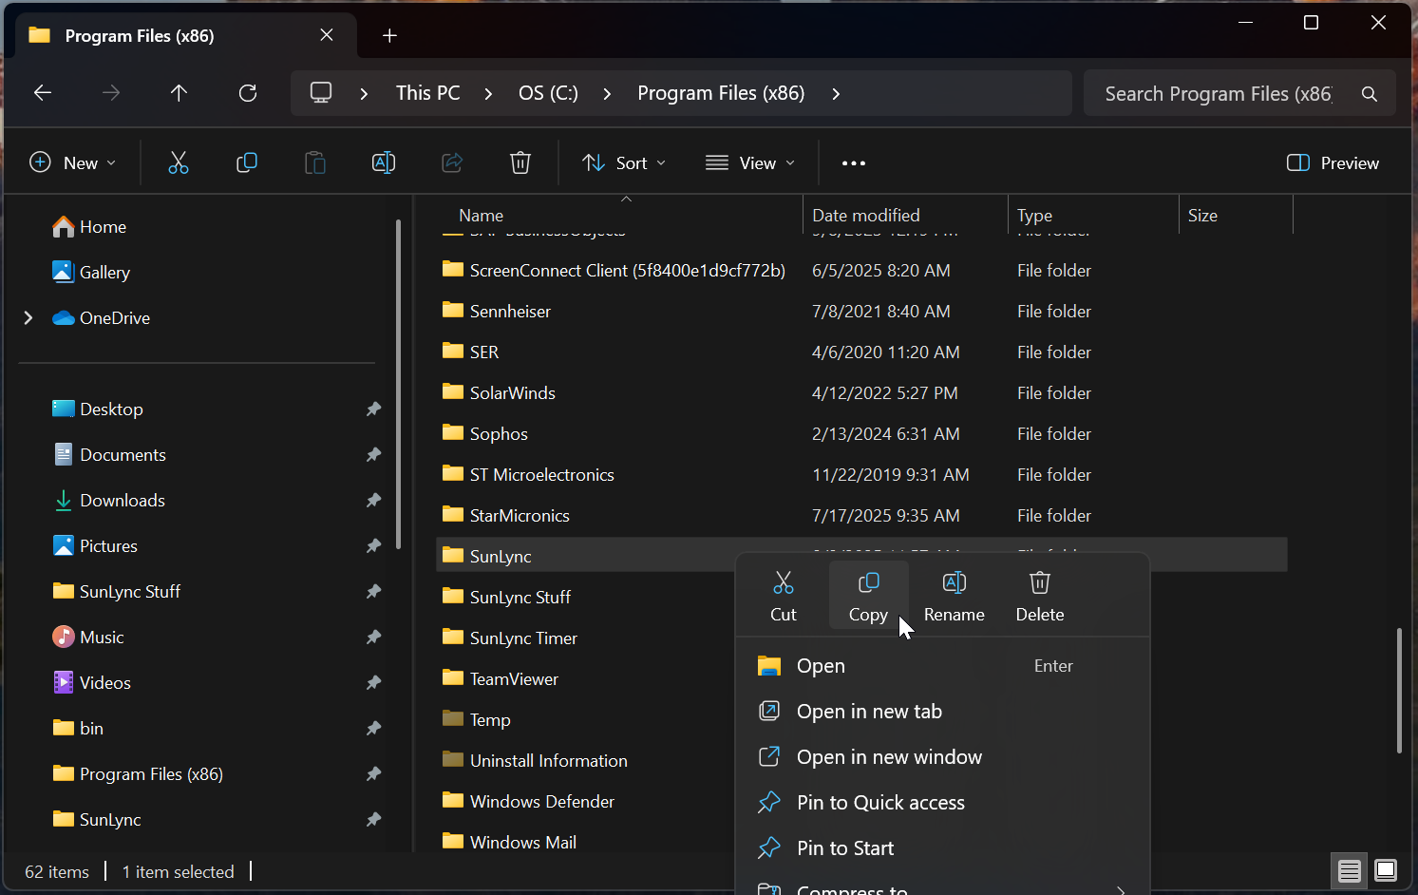
Start by copying the SunLync folder, “C:\Program Files (x86)”, and paste into the same folder.
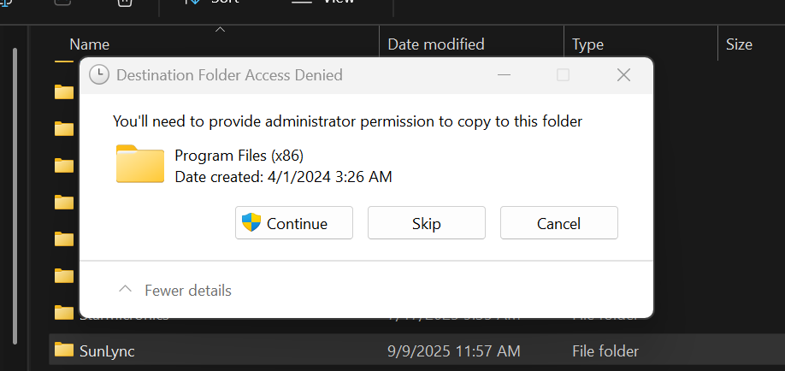
If asked, provide Administrator access for the copying.
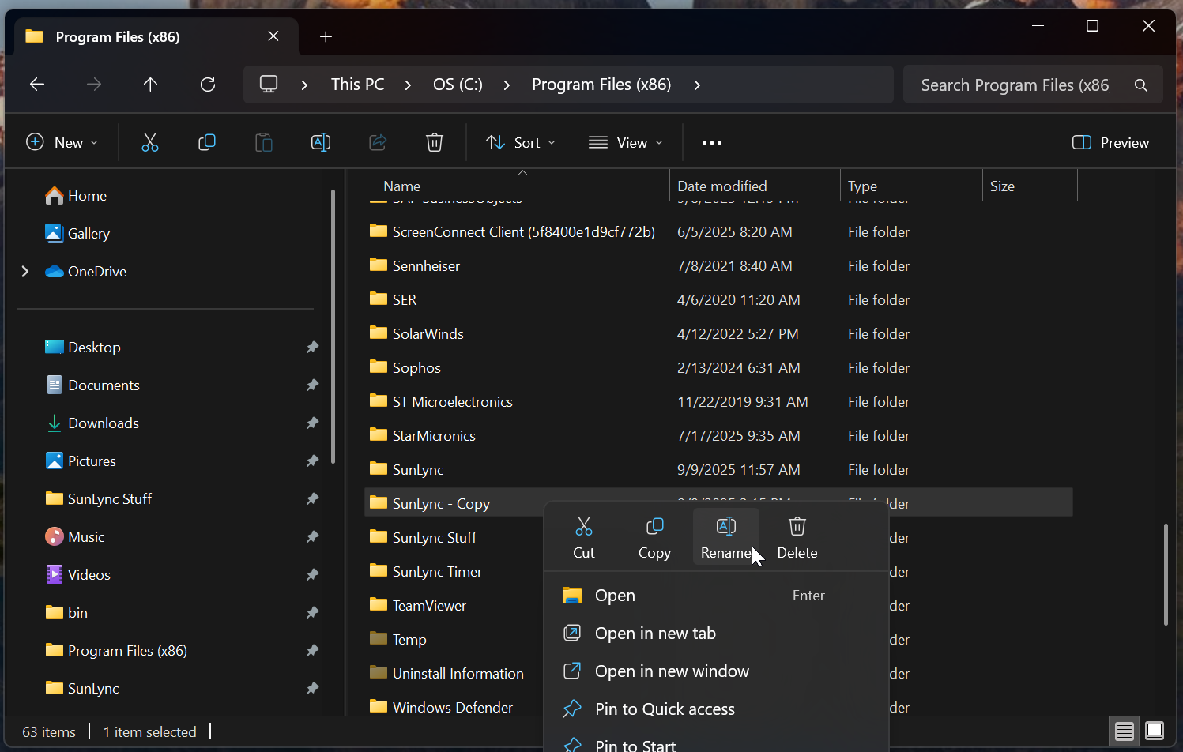
Next, rename the folder to something like “SunLync V9”.
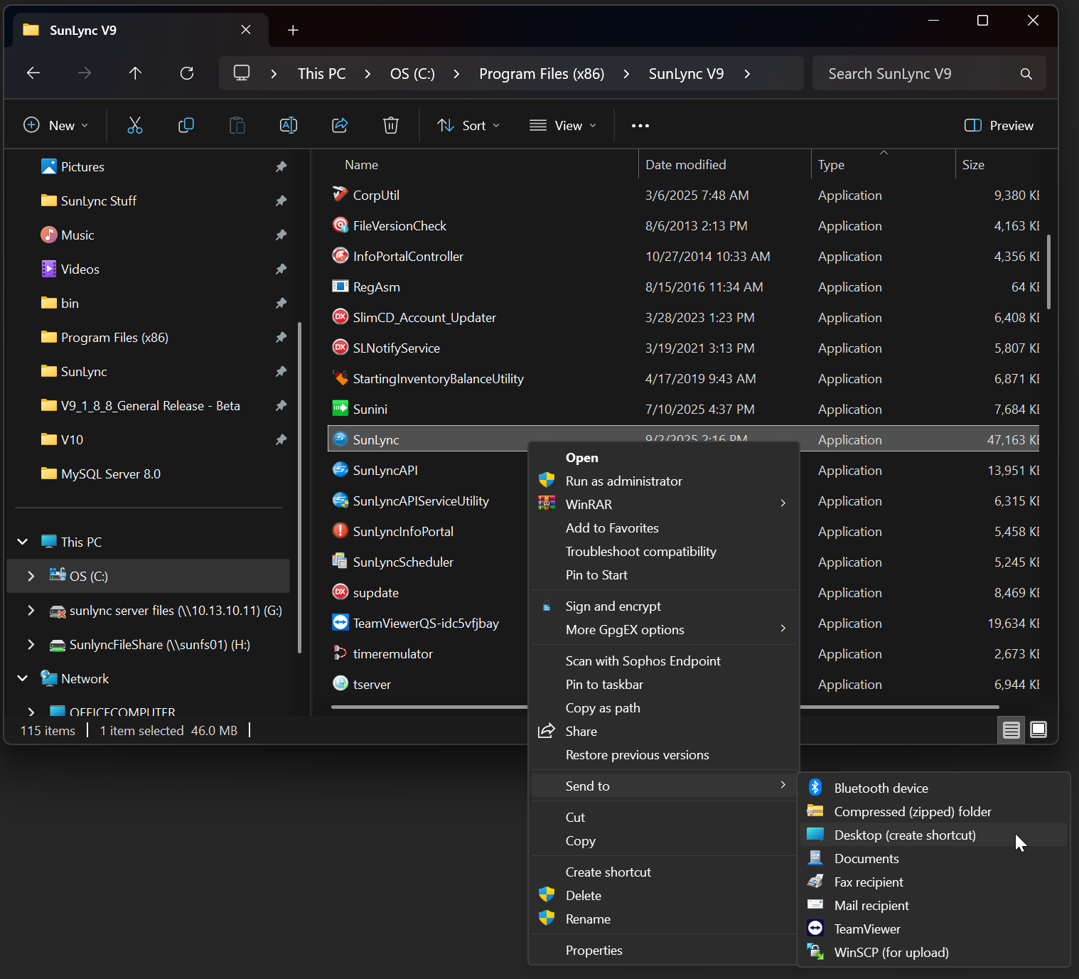

With the folder renamed, create a desktop shortcut of the Sunlync.exe file.
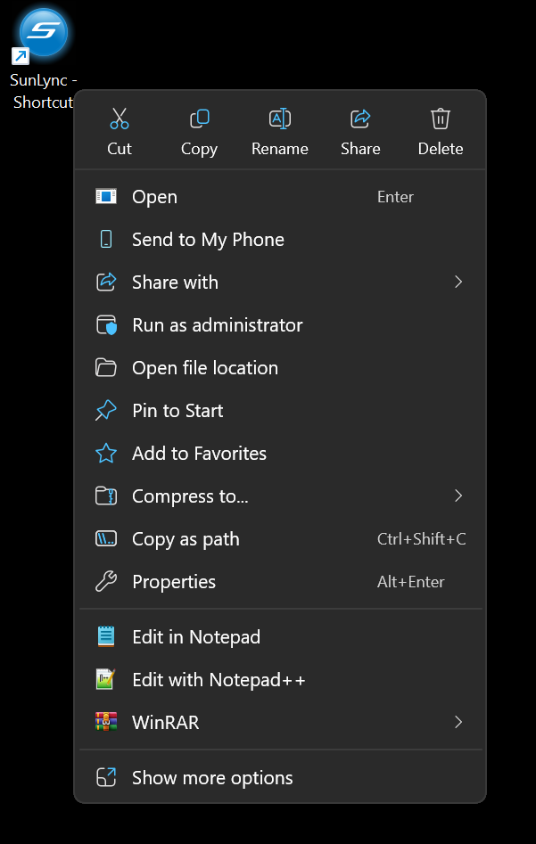
Then rename the shortcut to something like “SunLync V9”.

Uninstalling SunLync V9
Before installing V10 of SunLync. You will need to uninstall SunLync 9 from the computer.
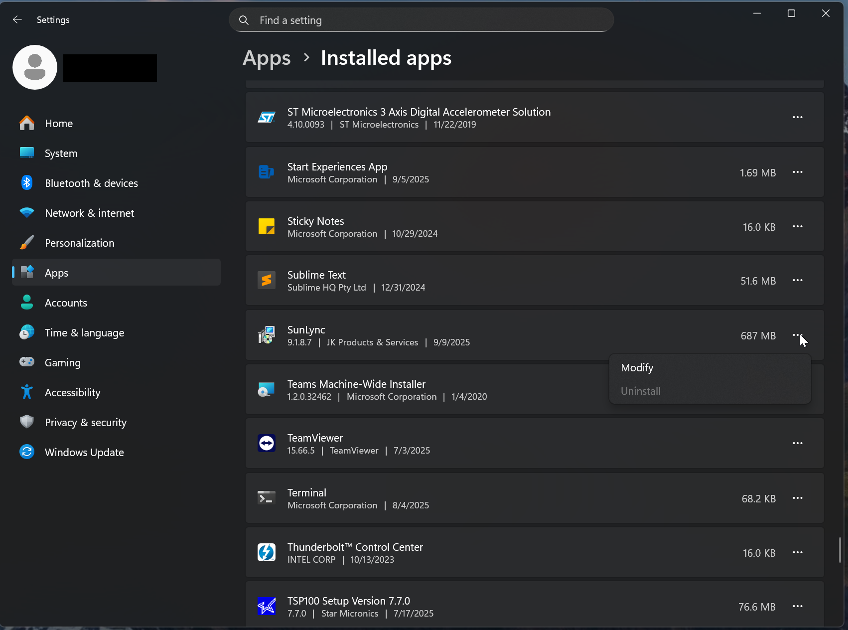
Go to the installed apps in the Windows’ Settings where you can “Modify” the program to remove SunLync.
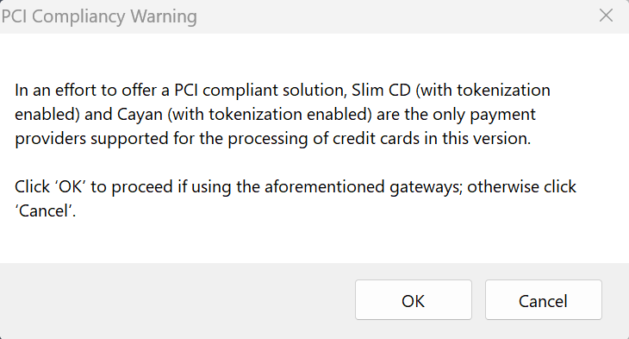
The first popup will be a PCI Compliancy Warning. Click Ok to move forward.

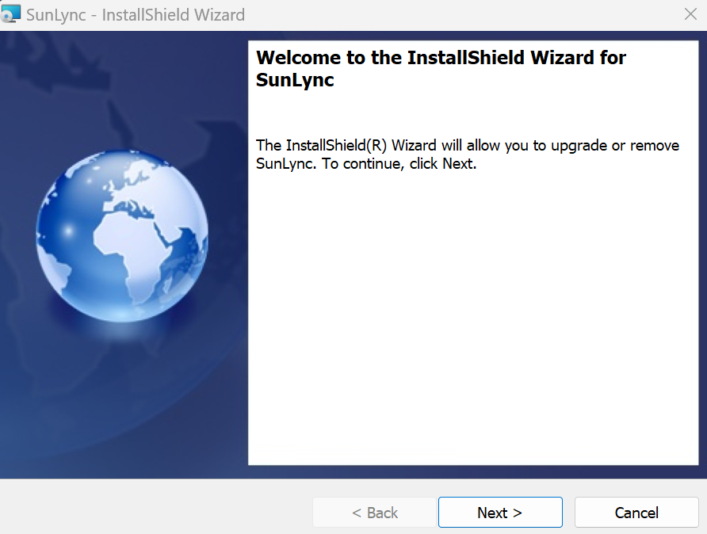
The InstallShield Wizard will now start. Click Next.
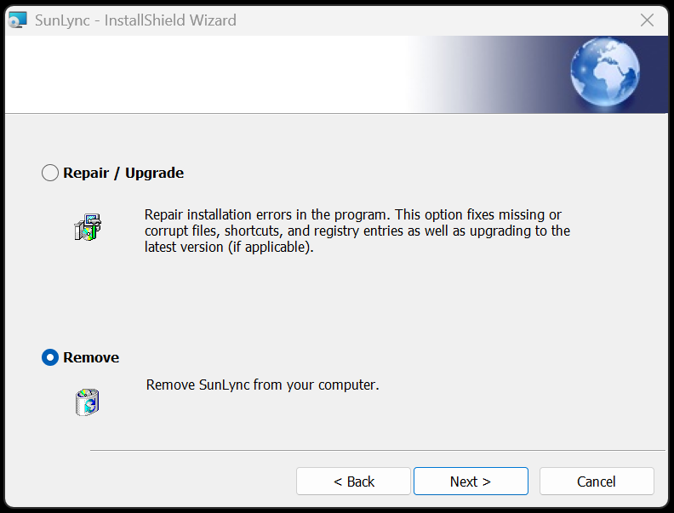
Select Remove followed by Next.
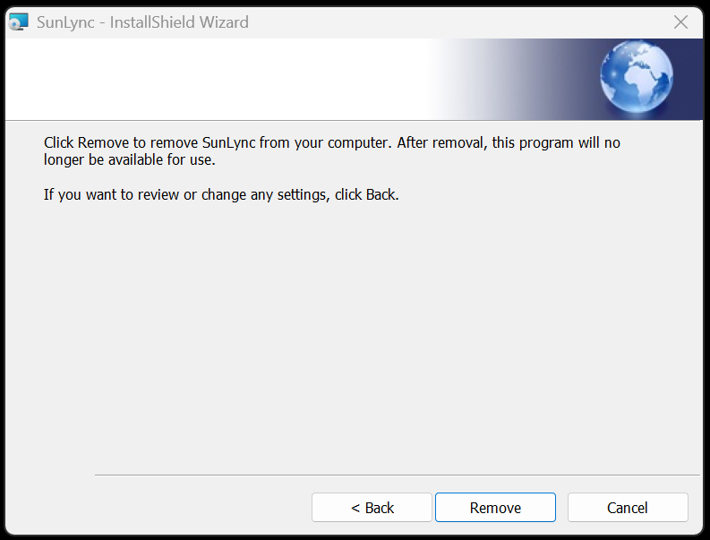
Then click Remove.
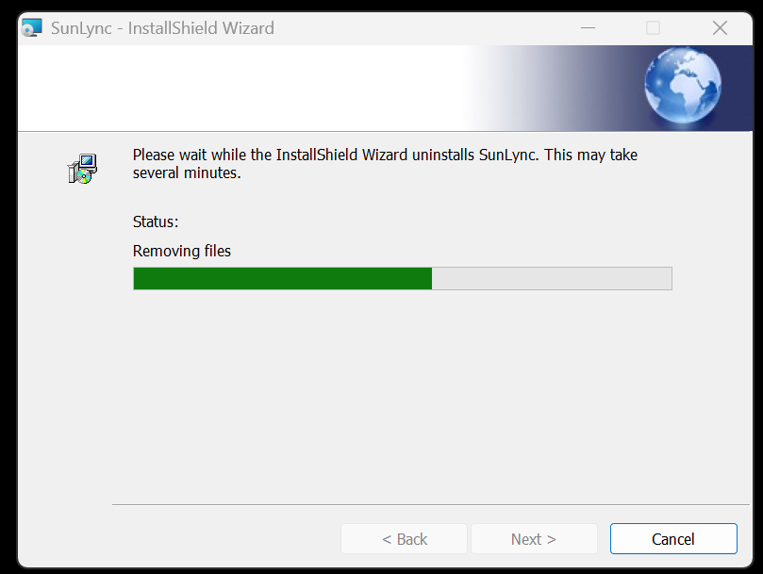
It may take the computer several minutes to remove all files and complete the uninstall.
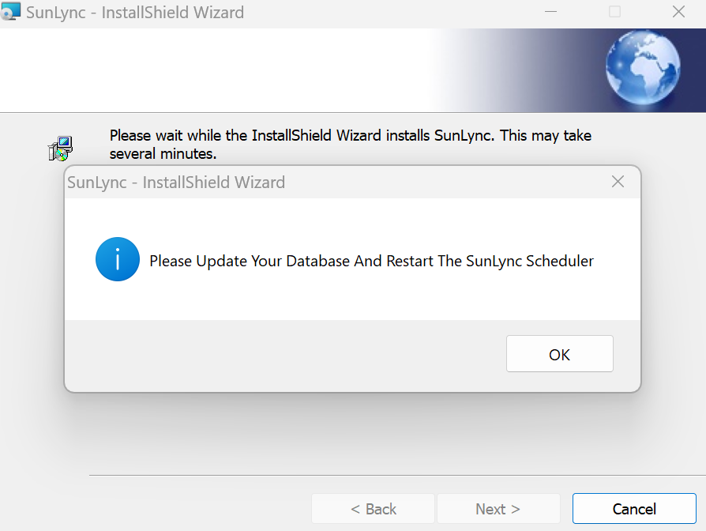
Once finished you should see a message asking you to update your database. Click OK
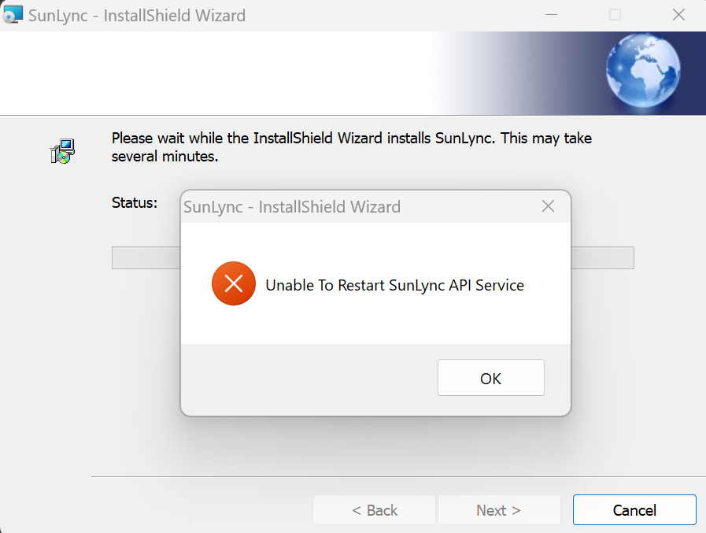
If you receive an error message that the SunLync Mail Service, Offline Download Utility, or API Service could not restart. Click OK as this is normal.
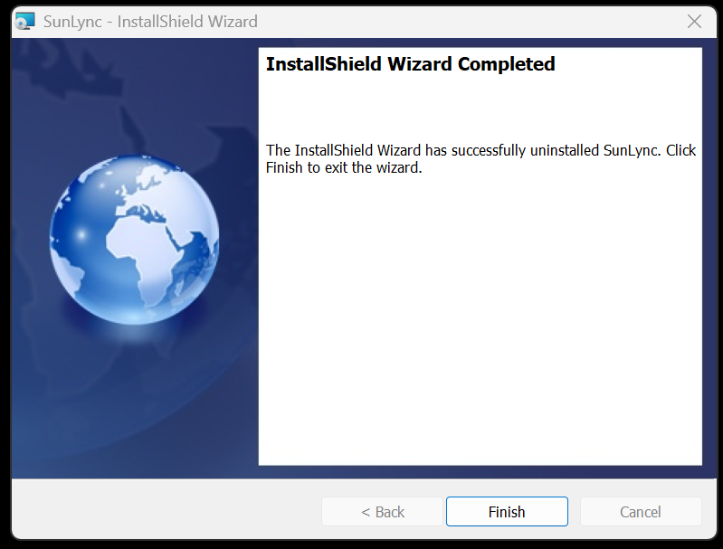
Now select Finish.

SunLync V10 InstallShield Wizard
With SunLync now uninstalled, you can safely install version 10.
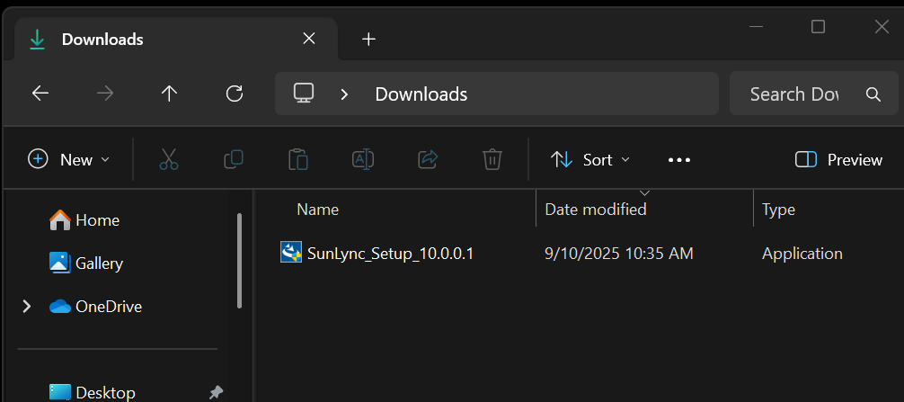
Start by running the SunLync V10 installer.
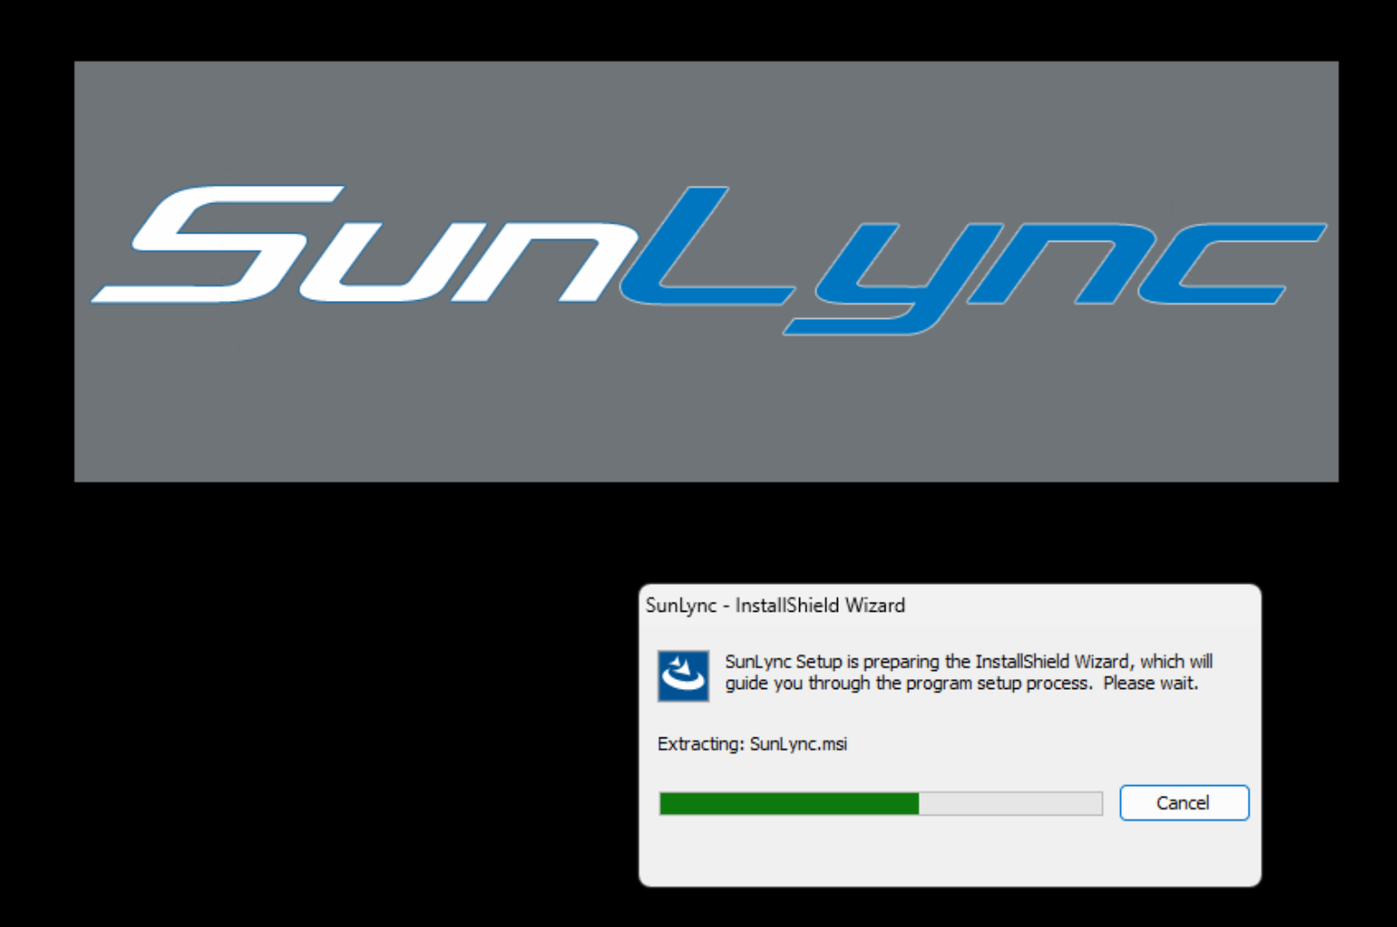
It may take a few minutes to start the InstallShield Wizard.
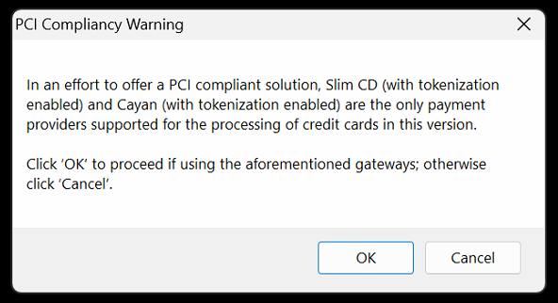
You will see a standard PCI compliance warning. Select OK to move forward with the installation.
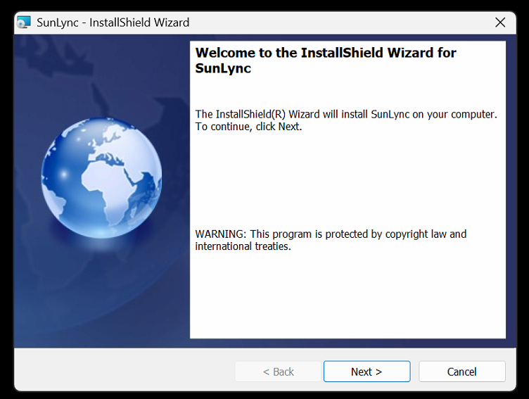
Click Next to move past the welcome screen.
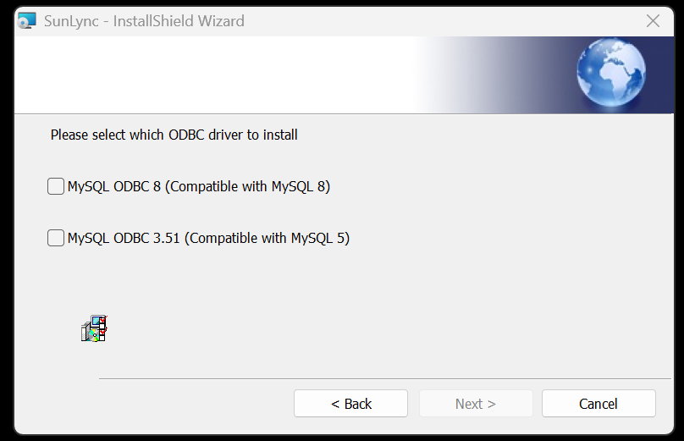
Select MySQL ODBC 8 if you are using MySQL 8 with SunLync. Select MySQL ODBC 3.51 for MySQL 5.
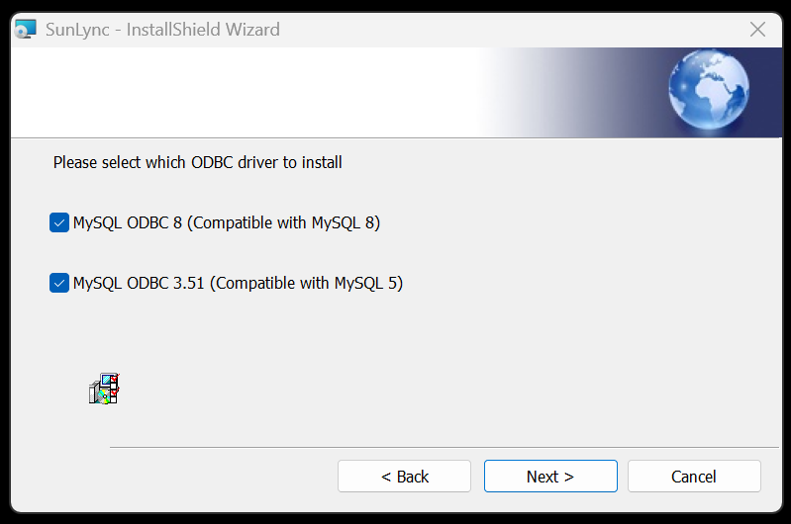
If you are unsure or if you need both, you can select both before clicking Next.
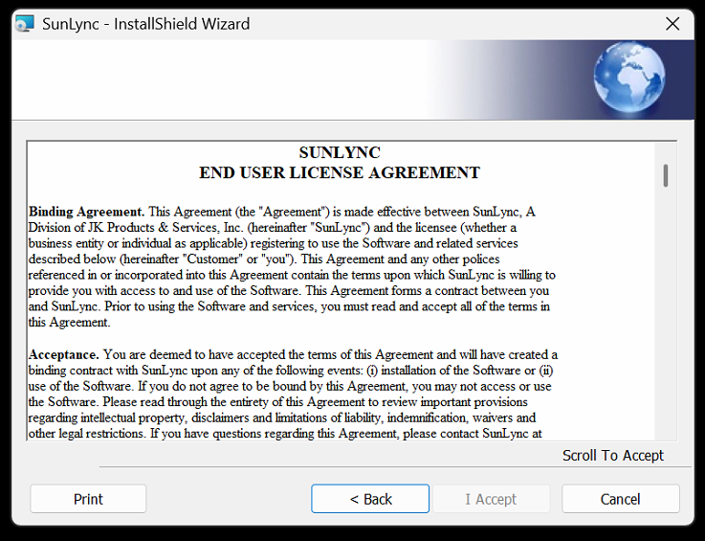
Before reaching the end user license agreement.
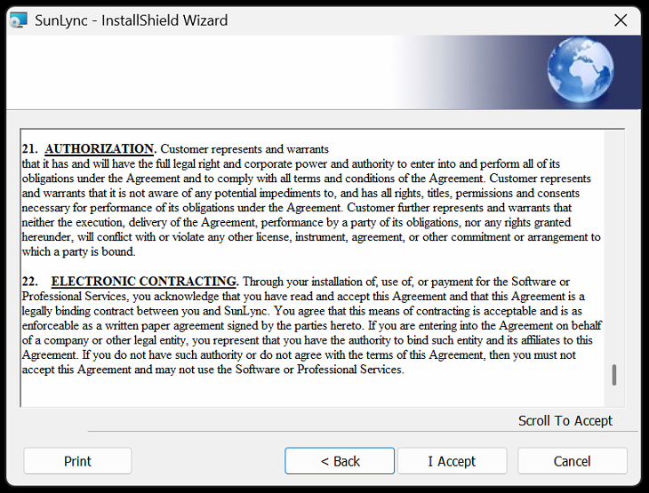
You must scroll to the bottom before you can click, I Accept.

Installing ODBC & VCRedit
If you selected to Install ODBC 3.5 and if Microsoft Visual C++ 2012 is not already installed on the computer. It will be installed first.
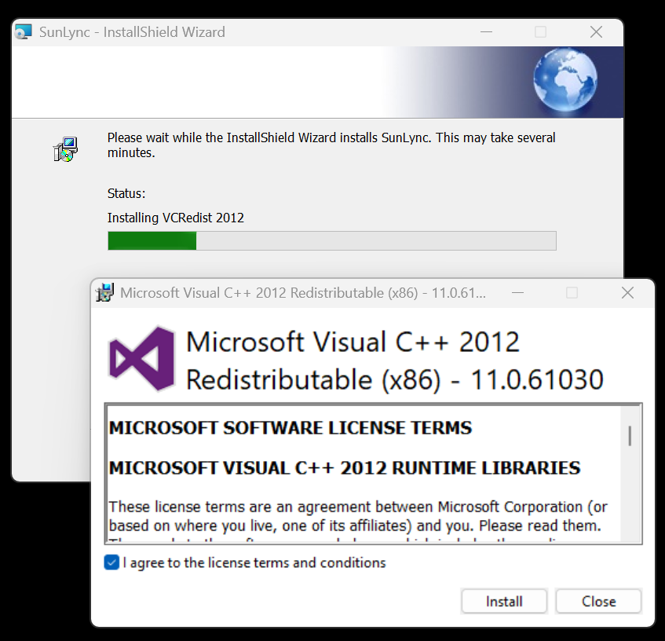
You must accept the license agreement before it can be Installed.
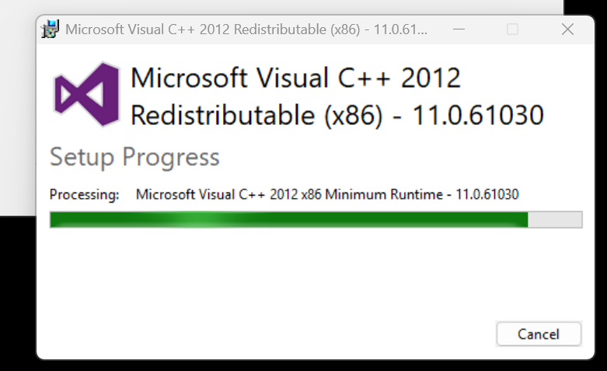
It may take a few minutes to process the installation.
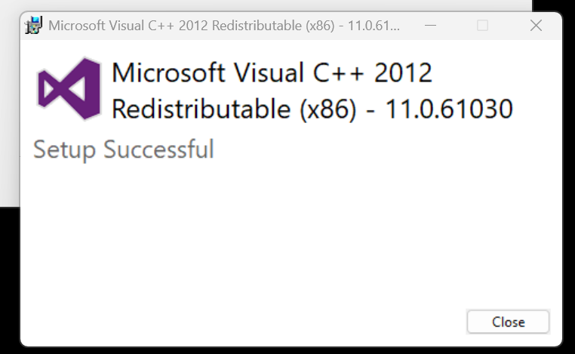
Once the setup is successful, you can close out the Window. The installer will now install ODBC 3.51 if it’s not installed yet.
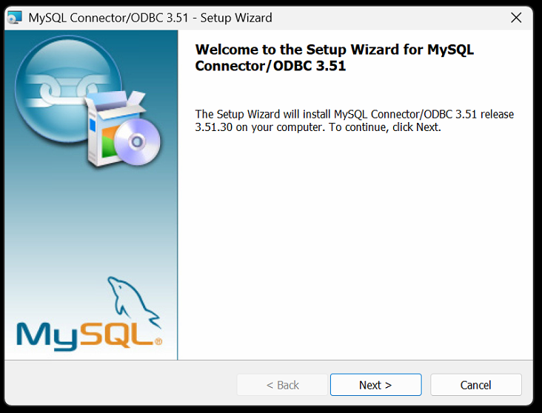
Start by clicking Next on the welcome screen.
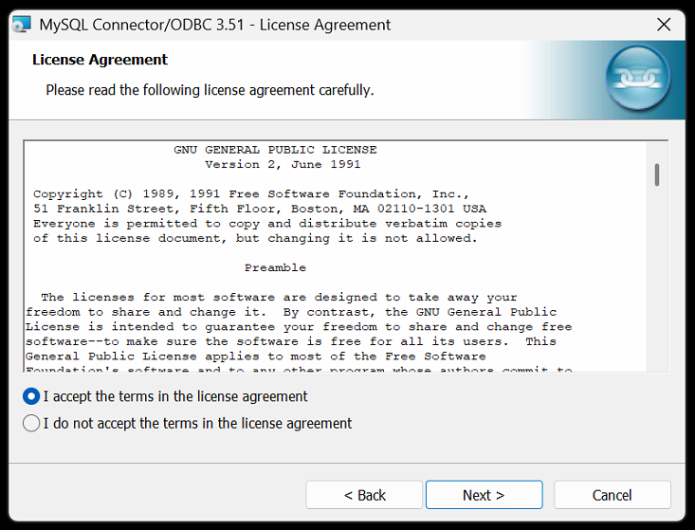
You must accept the software license agreement before you can select Next again.
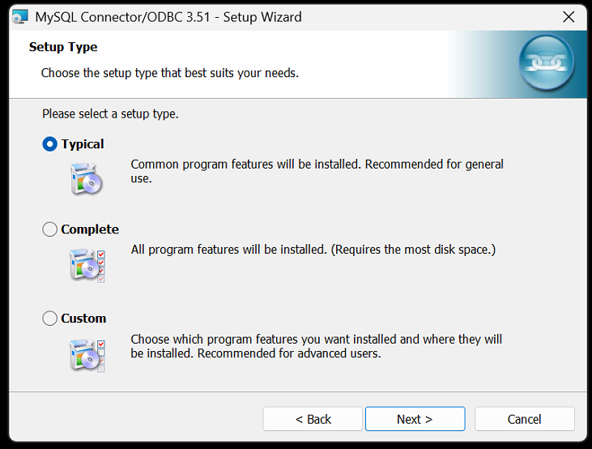
The installer will auto select Typical, and this is what we want. Select Next once more.
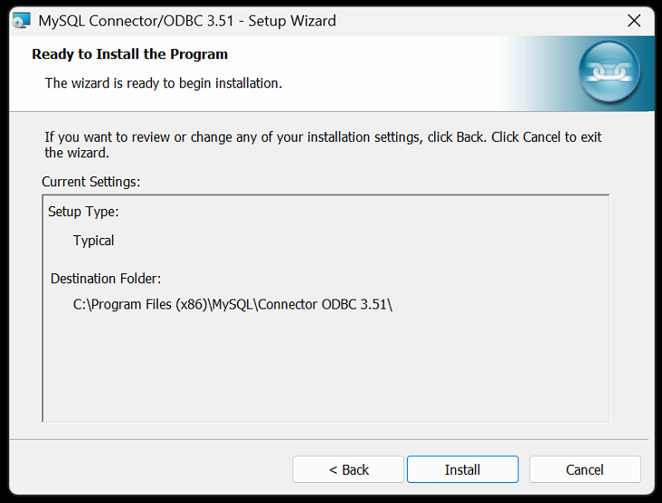
Now Install.
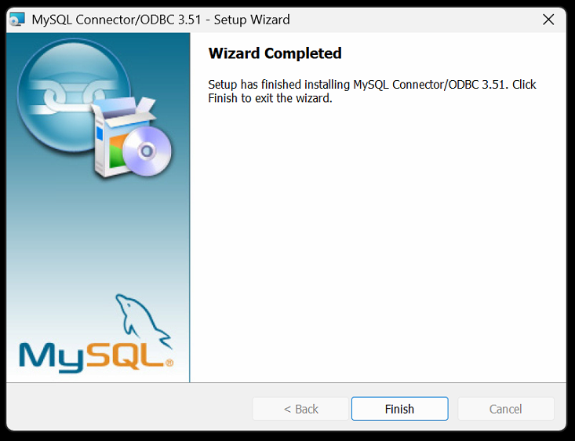
It may take a moment before you can Finish the install.
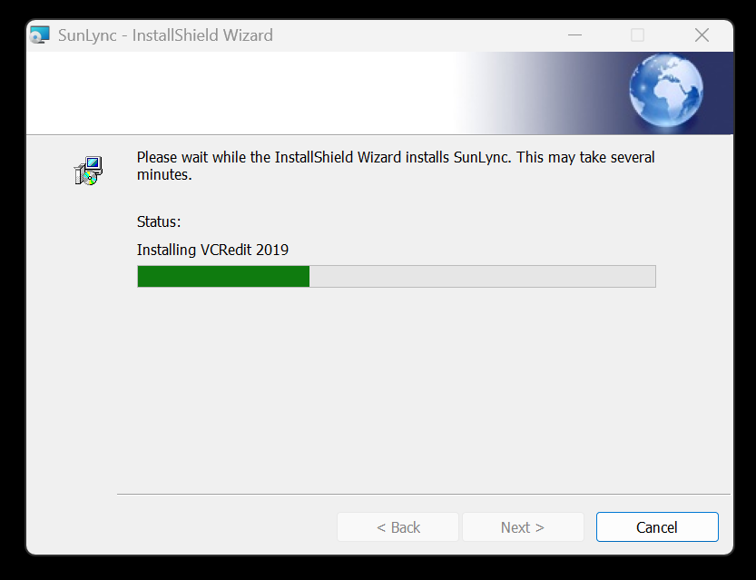
Next, VCRedit 2019 will be installed if you elected to install ODBC 8.0.
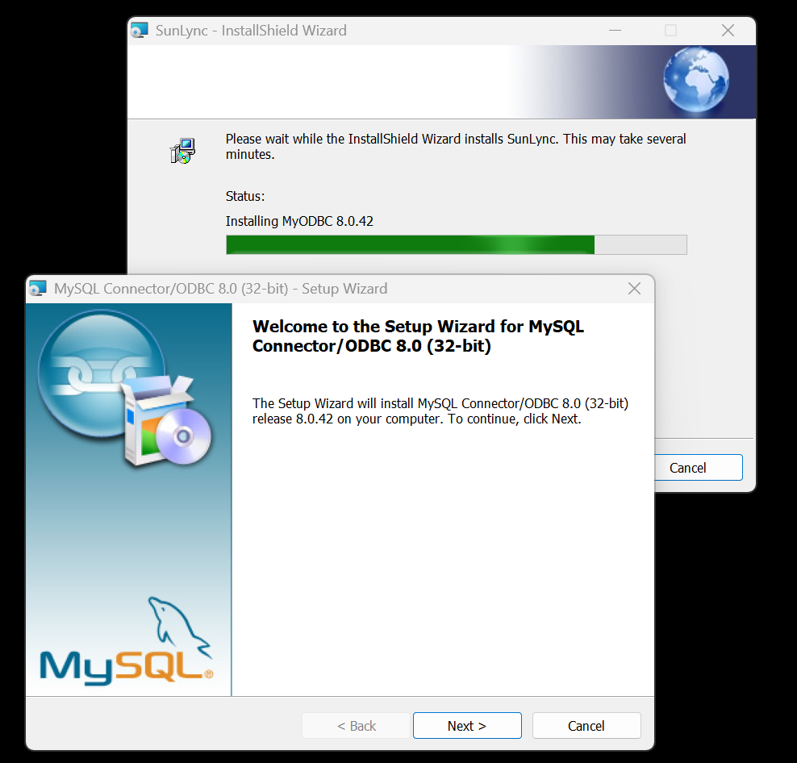
Followed by the ODBC 8.0 installation. Click Next to move forward.
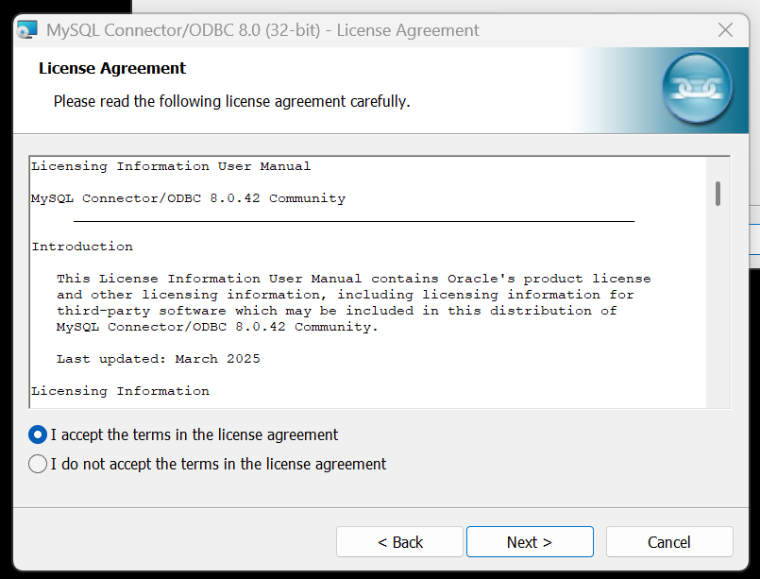
Once you accept the license agreement, you can click Next.
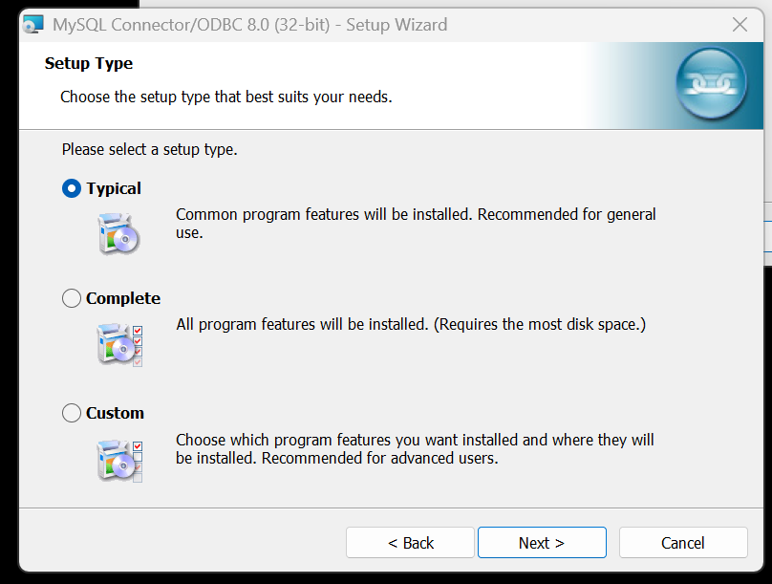
The installer will auto select Typical, and this is what we want. Select Next once more.
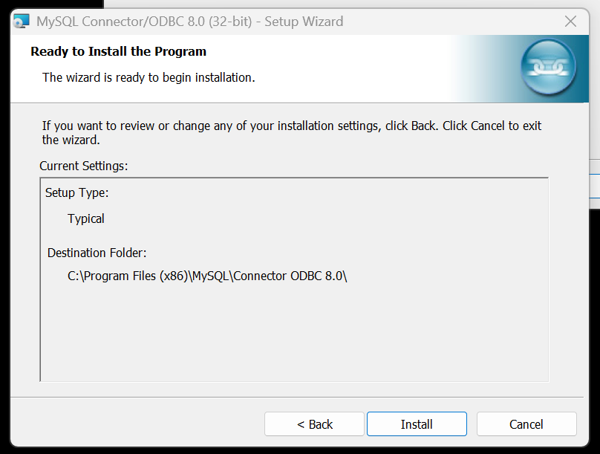
Next, select Install.
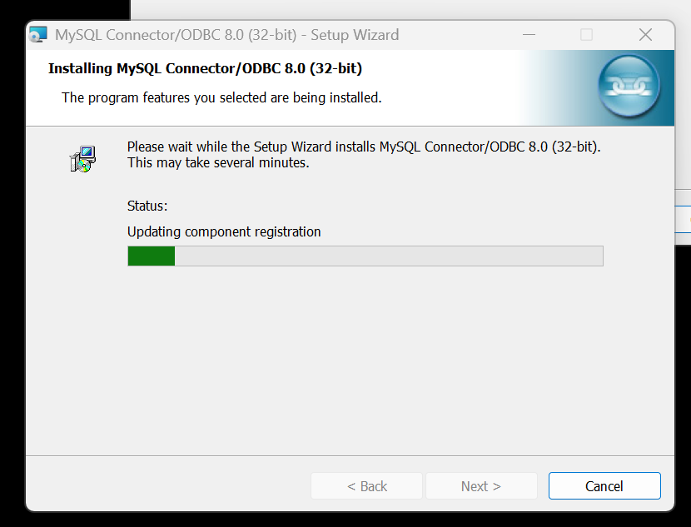
It may take a few minutes for the installation to finish.
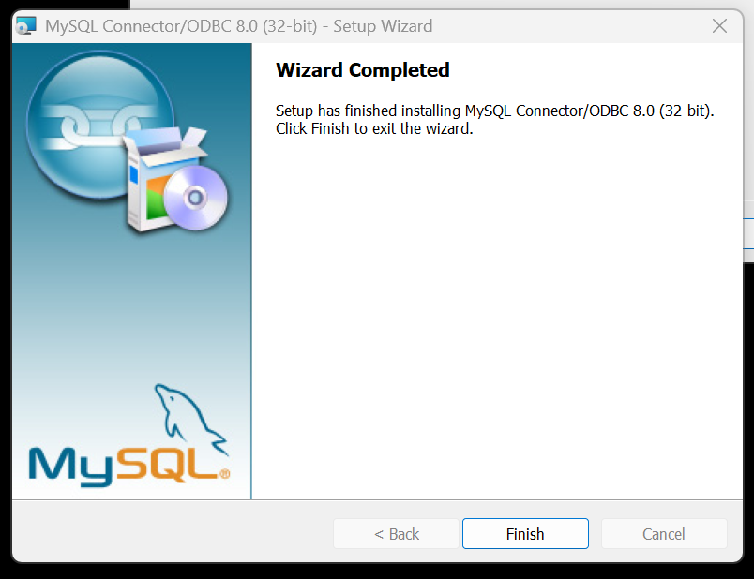
When it’s done installing, select Finish.

SunLync Installation
With all the dependencies installed, the SunLync software will now be installed.

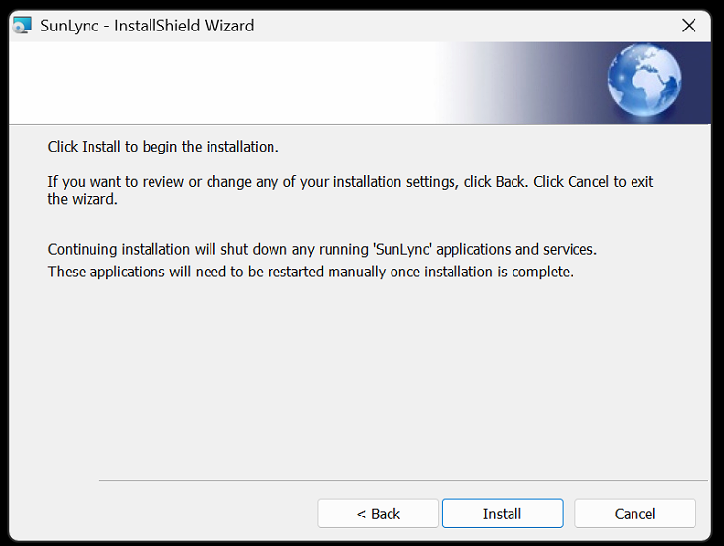
Select Install.
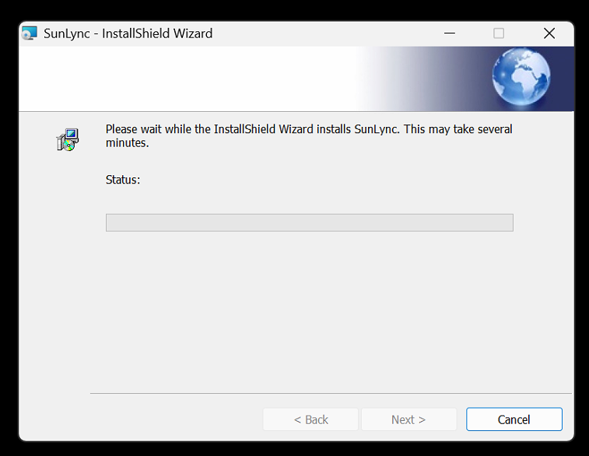
It may take a few minutes to install. You may even see a command prompt window briefly flash and disappear on your screen. This is a normal part of the installation.
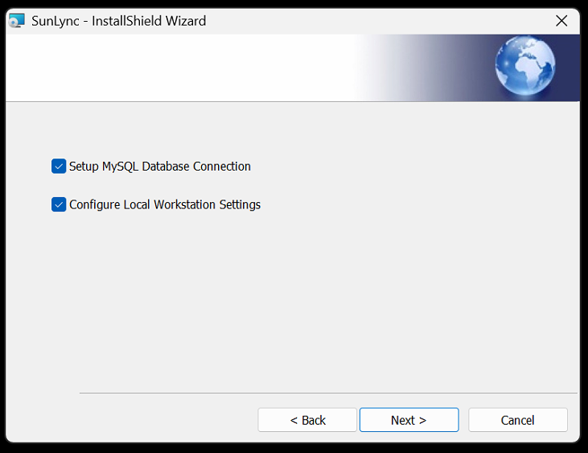
The computer should still have the V9 settings for MySQL Database Connection and the Local Workstation Settings.
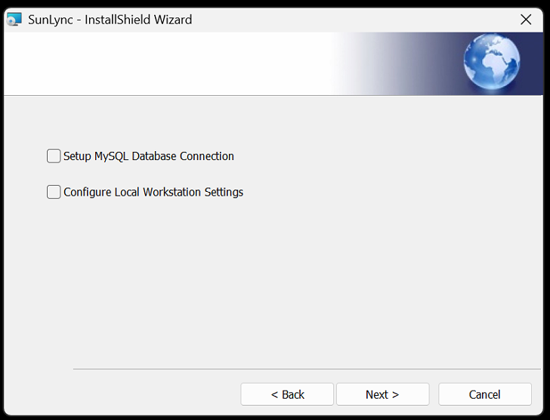
Uncheck both options and skip.
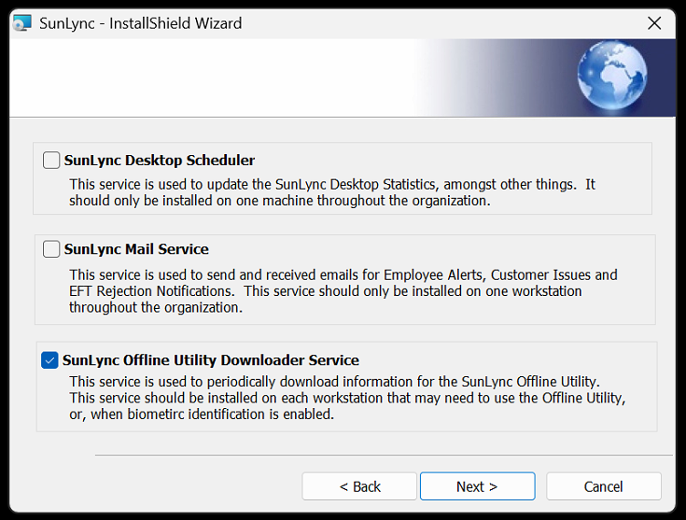
The installer will automatically checkmarks to install Offline Utility. If this computer is a POS computer that is off-site from the server, or if the computer will be using a biometric fingerprint reader. You should install it now.
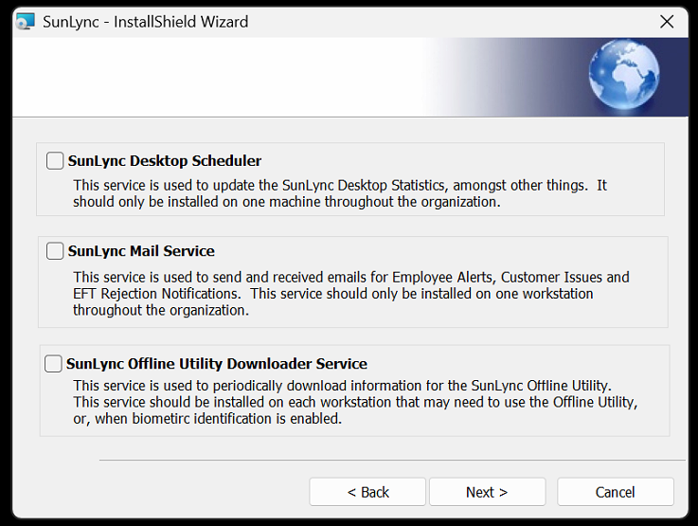
Otherwise, un-checkmark the offline utility to skip installing it.
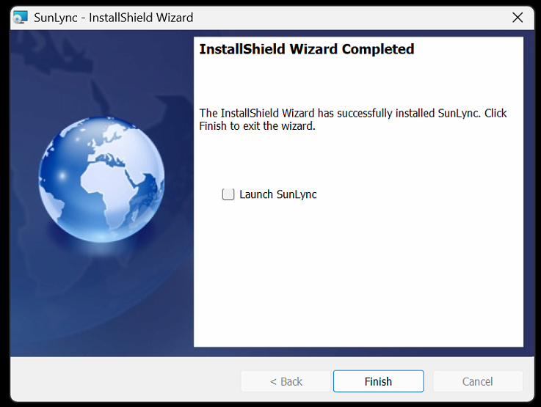
If this was the server computer, skip launching SunLync until you have completed the Updating Database to V10 section below. Then click on Finish to close the install wizard.

Updating Database to V10
The database update needs to be completed on the server computer and should be completed after updating the SunLync software on the server. Before installing V10 on any other computers.
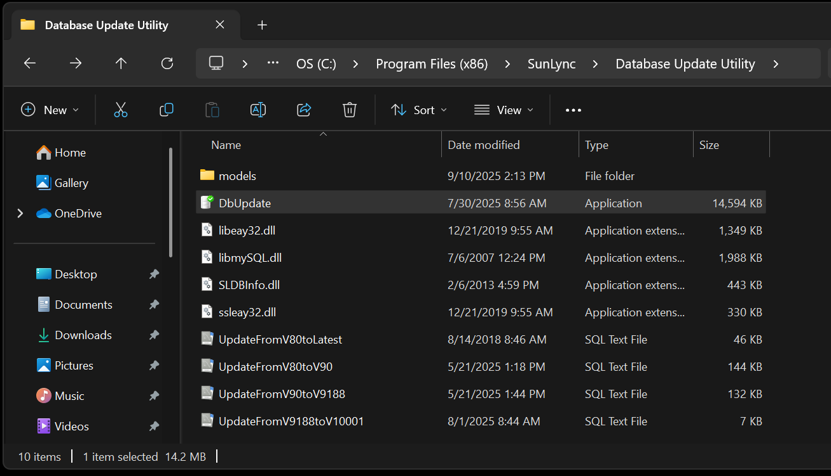
To update the SunLync database, open the SunLync Database Update Utility. Located in the SunLync folder. "C:\Program Files (x86)\SunLync\Database Update Utility\DbUpdate.exe"
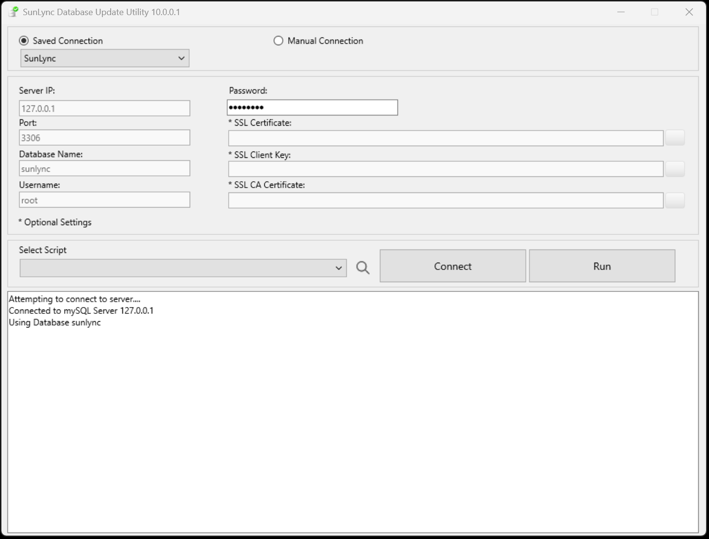
Using either Saved Connection or Manual Connection, fill in the server settings and then Connect.
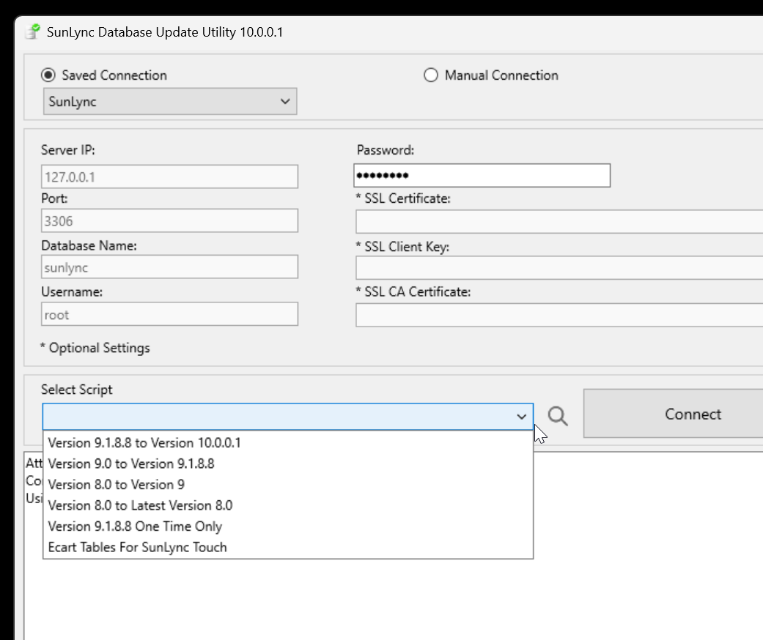
Select script “Version 9.0 to Version 9.1.8.8”.
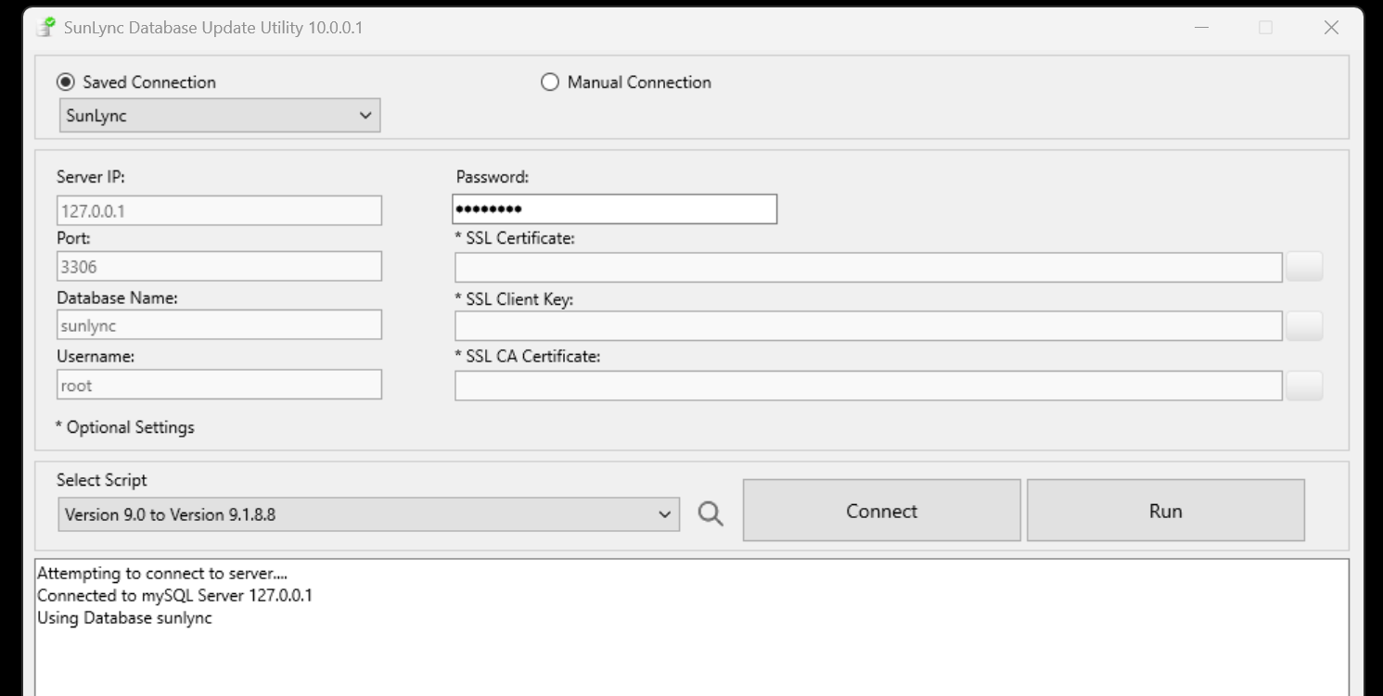
Click Run.
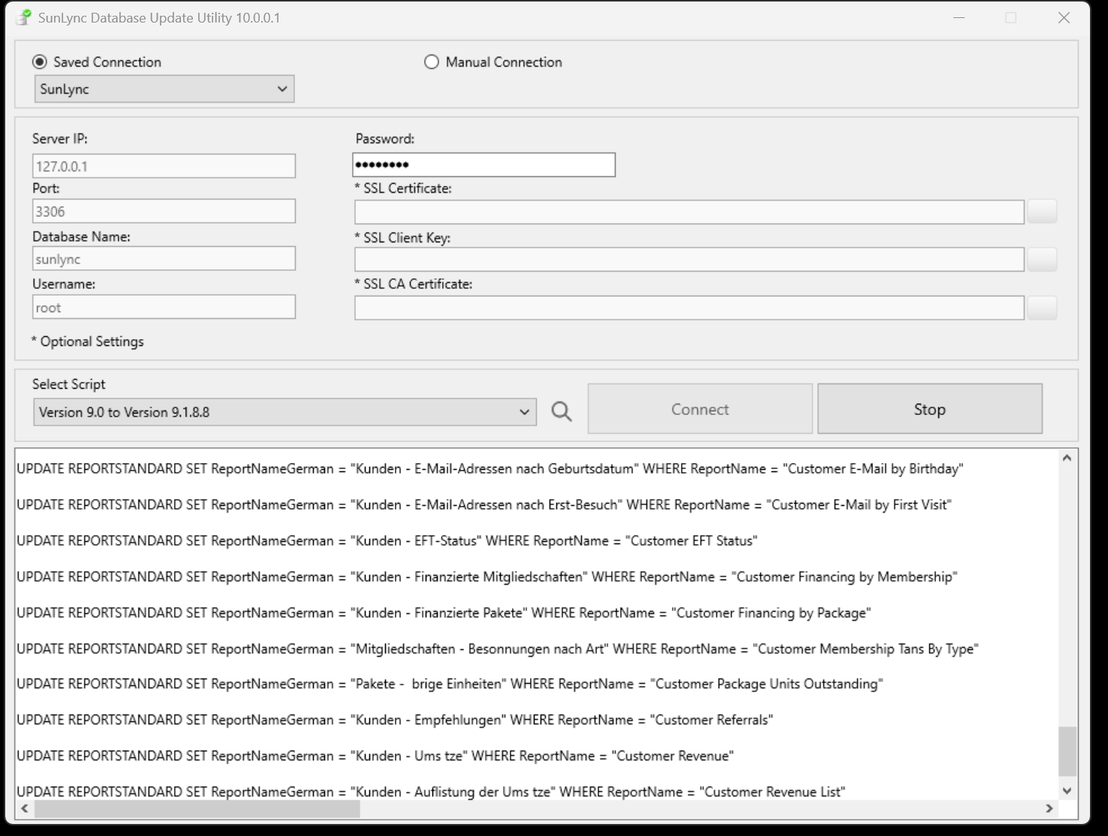
It may take several minutes and at the end the Stop button changes back to Run.
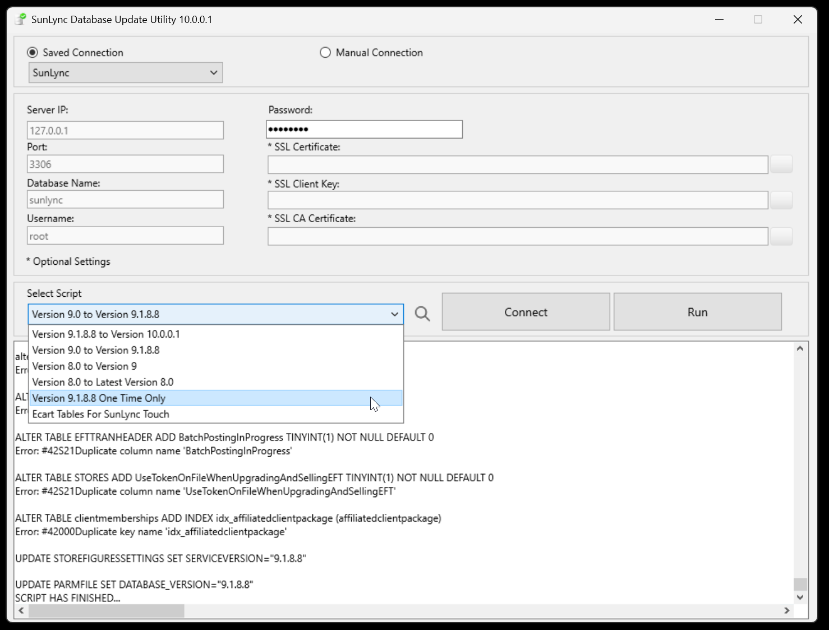
Next, select and run the “Version 9.1.8.8 One Time Only” script.
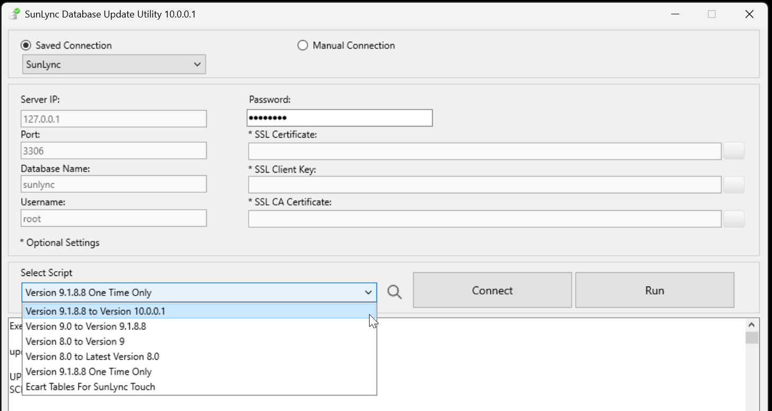
Then finally, run the “Version 9.1.8.8 to Version 10.0.0.1” script.
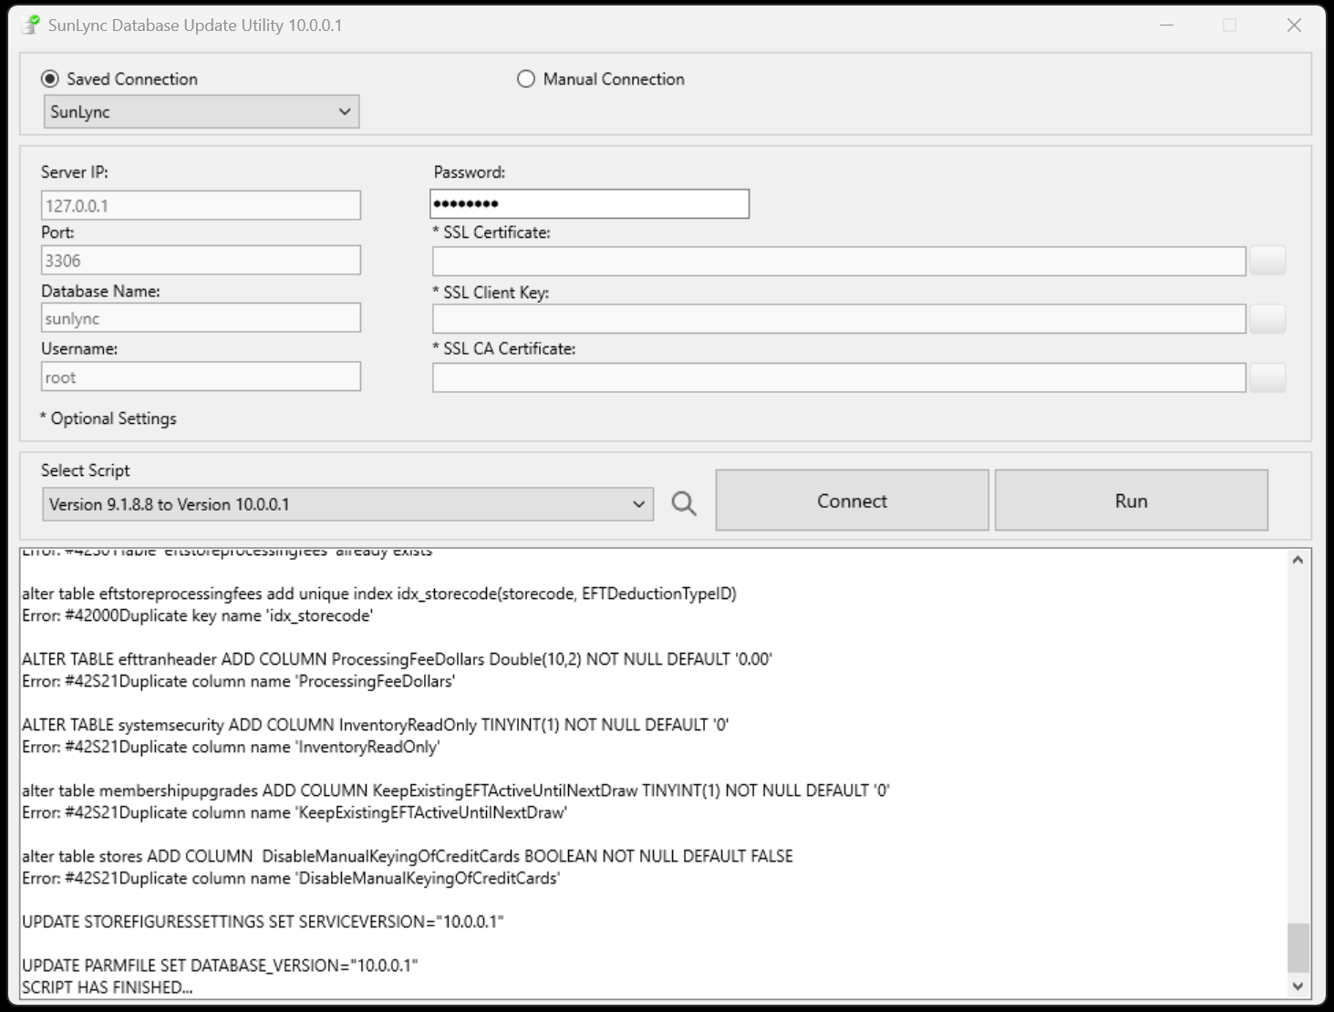
The text window will say that the Script has finished. The server and database are now finished being updated to V10.

