

SunLync Credit Card Terminal Install Guide

These settings (including the ones in Back Office) are per-computer. Make sure to complete the steps on each computer that will be using a card terminal. Including IP address-based credit card terminals.
USB connected card Terminals are configured via Sun.ini. Card terminals are either encrypted or not. To find out which you have. Open notepad on the computer and swipe a card. Non-encrypted will show the card info. While encrypted card readers will list a series of randomly generated numbers and letters.
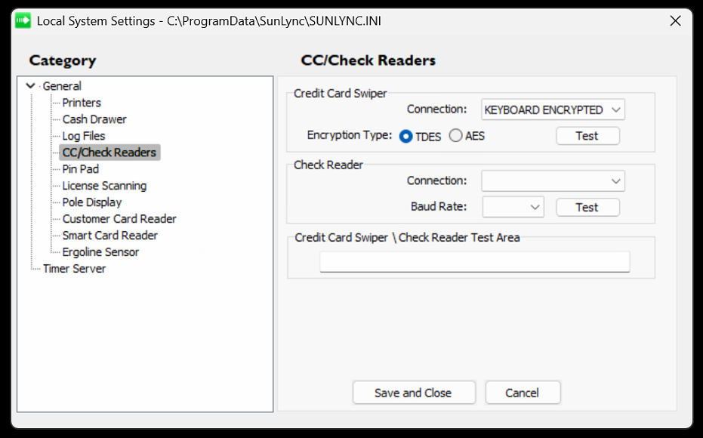
Keyboard Encrypted – Most modern card terminals will be encrypted, and use the TDES setting.
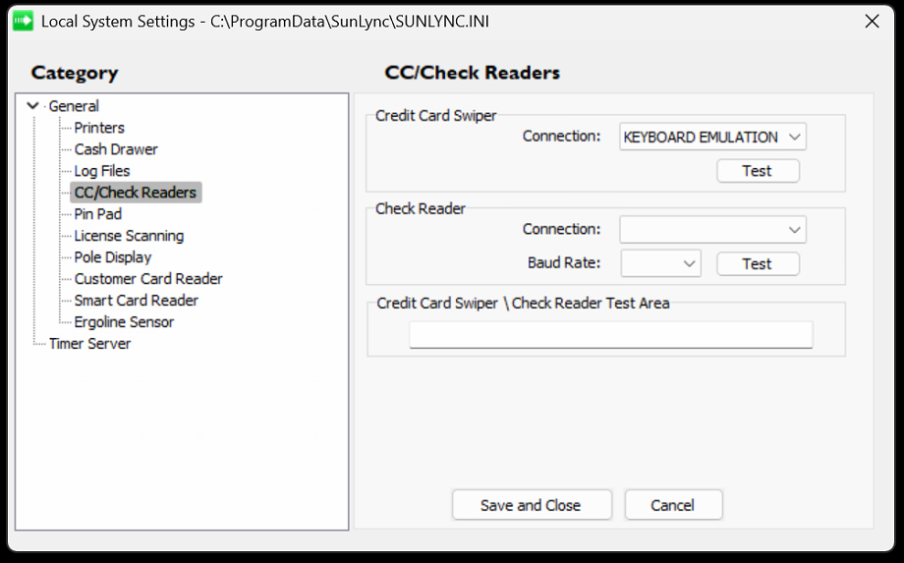
Keyboard Emulation – Data from the card reader is scanned and sent the same as typing on a computer. Used on some legacy card terminal devices.
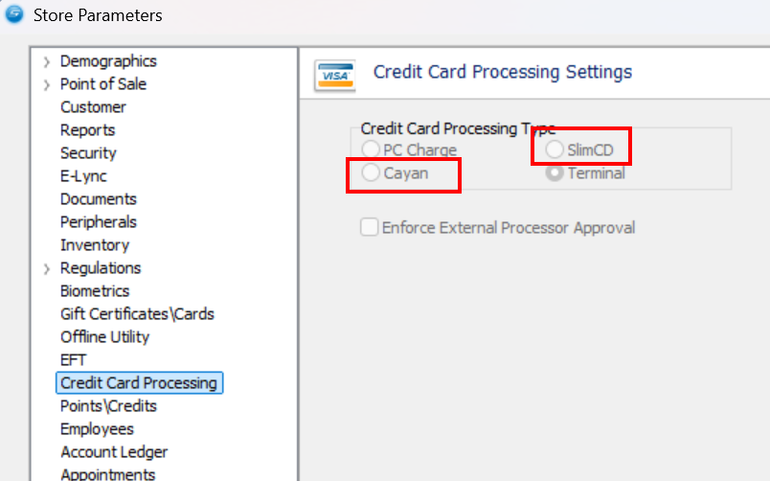
Selecting Cayan (GPI) or SlimCD as your credit card processor under Store Parameters in Back Office. Will give you extra Back Office settings for the card terminal under the Customers tab.
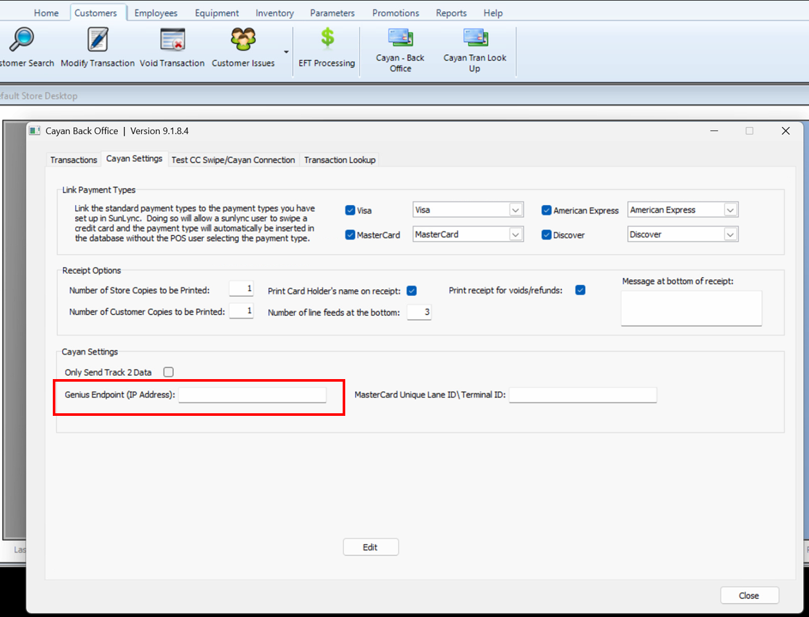
Genius terminal devices from Global Payments Integrated (GPI) will be set up via the Cayan Settings tab, using the IP address. Located under Customers, then “Cayan – Back Office” settings.
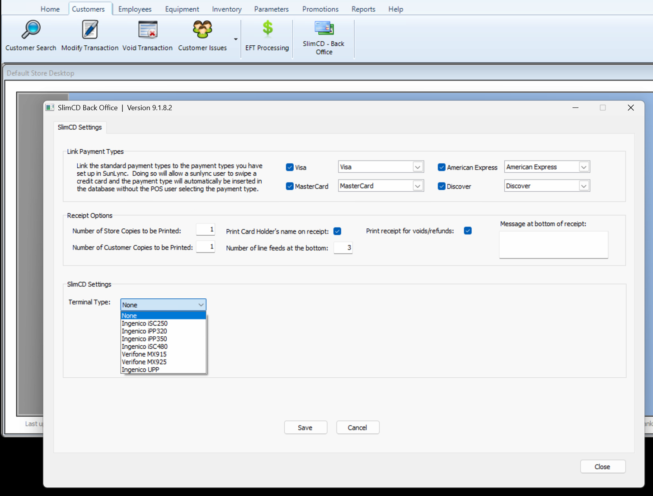
While many legacy SlimCD card terminals will be set up in the SlimCD Settings tab, under the “SlimCD – Back Office” settings.

Receipt Printer
SunLync is compatible with the Star TSP100 Series USB and similar Star printers. If the computer is physically connected to the receipt printer, then the Star Utility program should have a COM port assigned within the Serial Ports settings
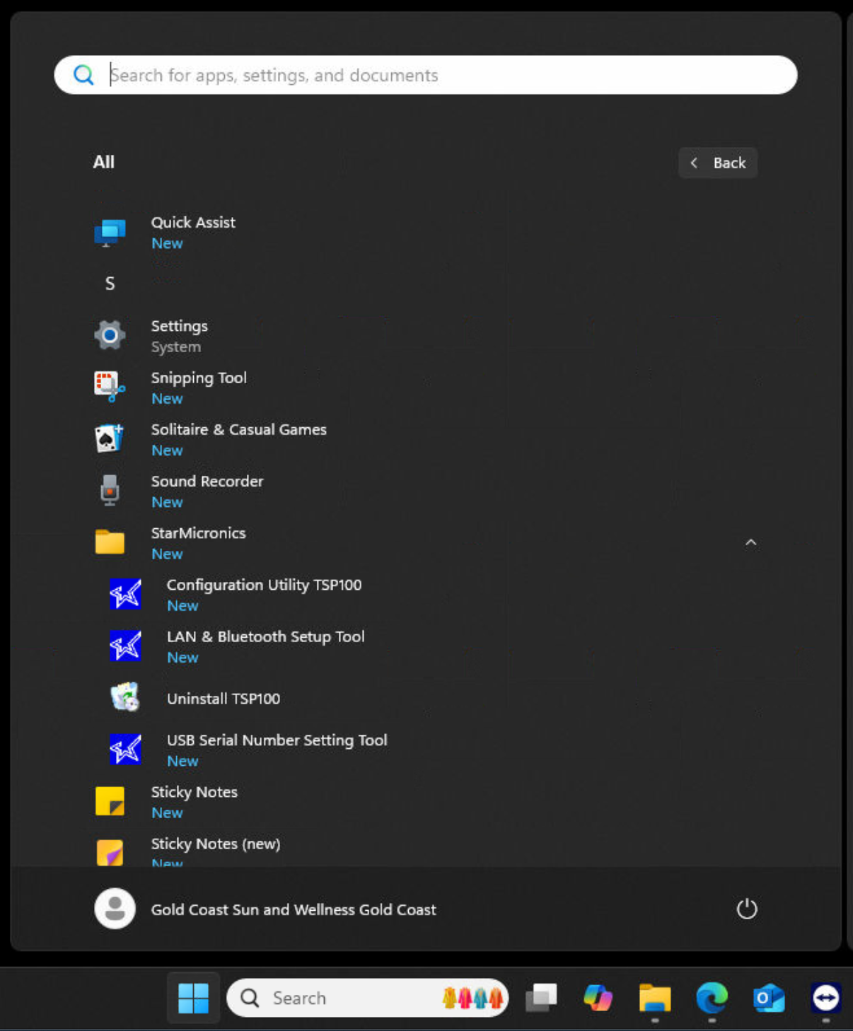
With the Configuration Utility installed. Start the Configuration Utility TSP100 program.
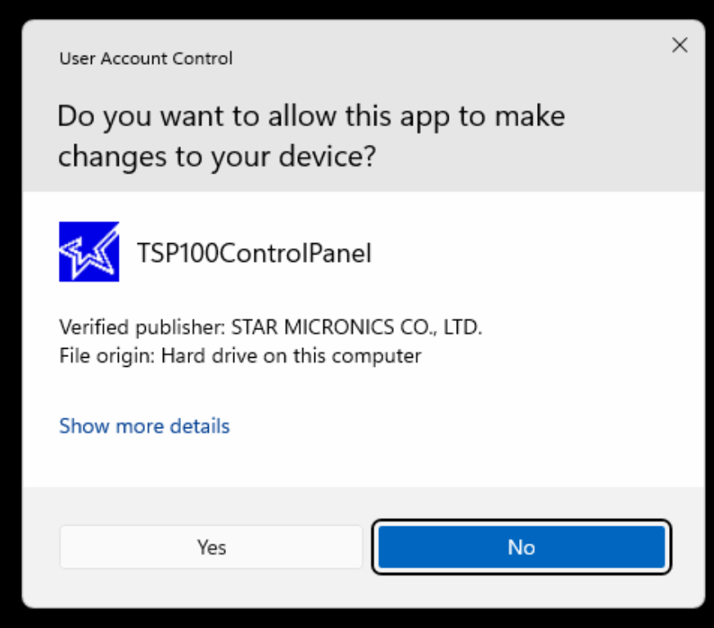
Select Yes to the User Account Control permission request.

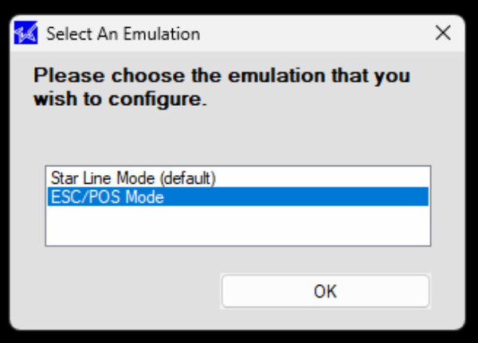
Select ESC/POS Mode, before clicking OK.
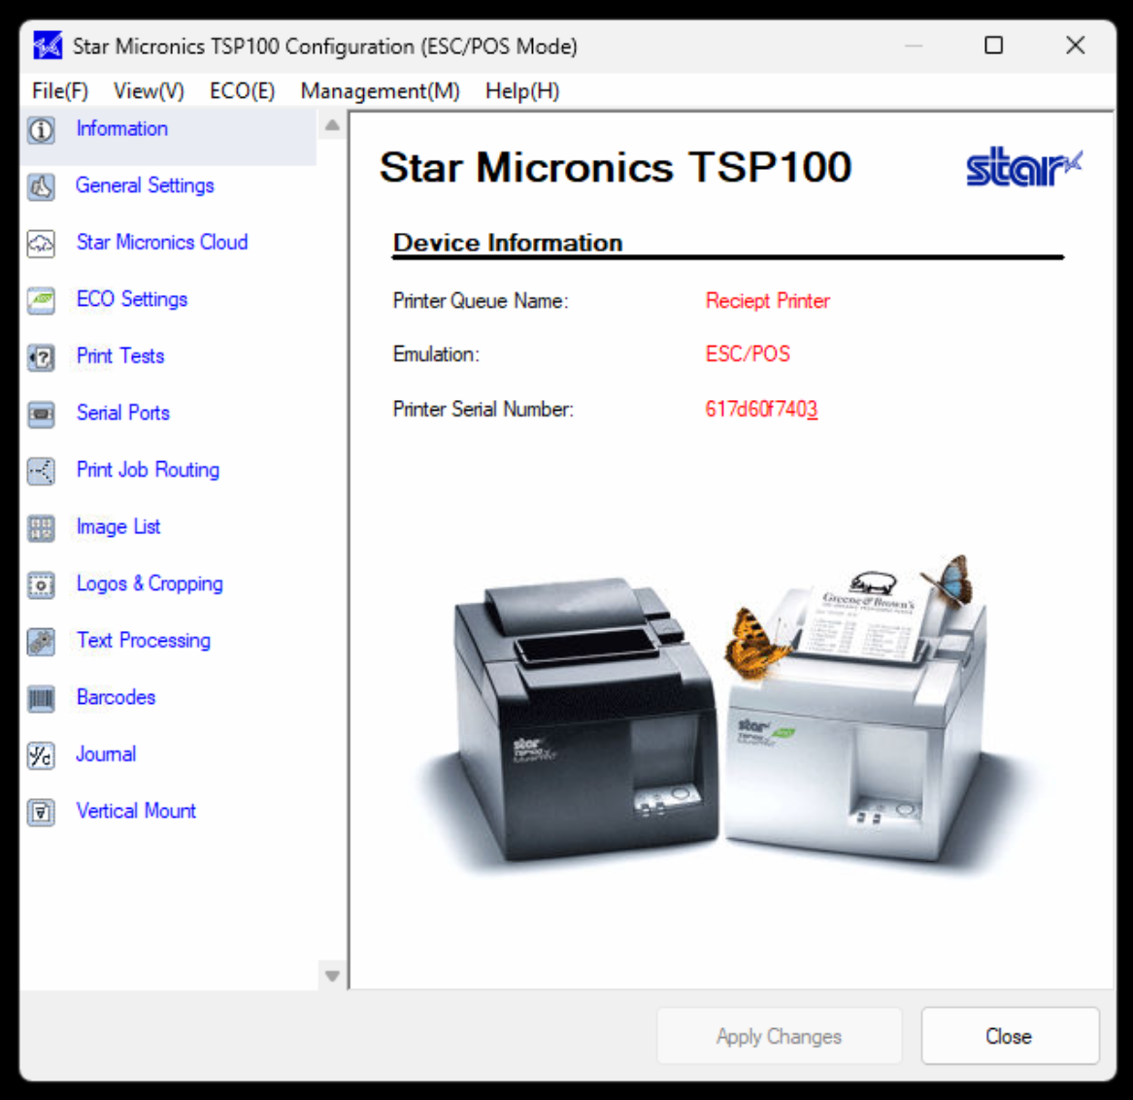
Now select the Serial Ports settings.
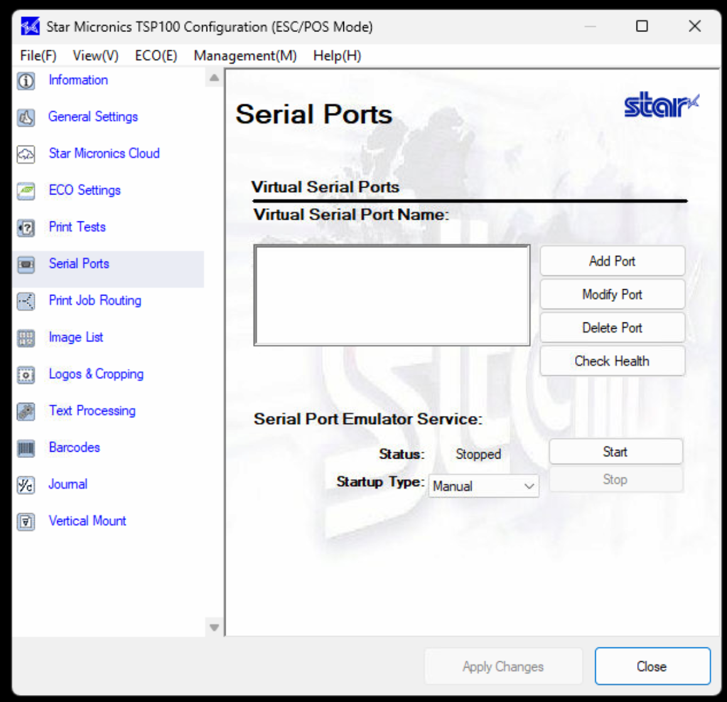
Select Add Port.
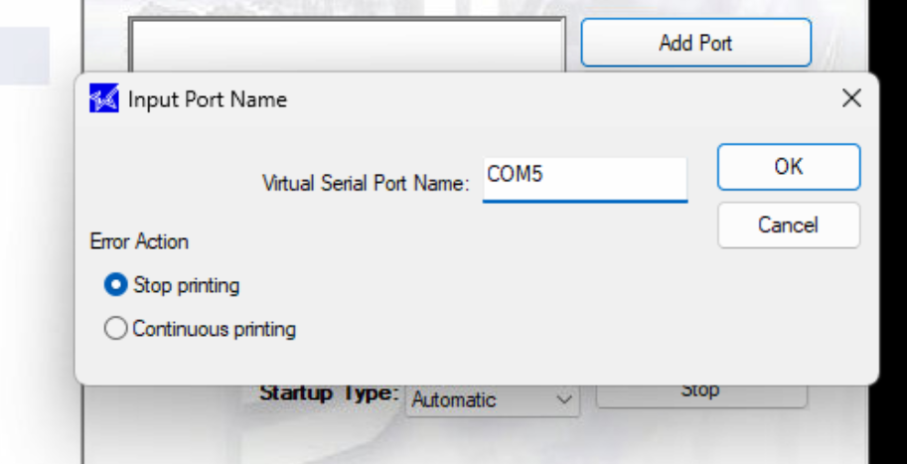
Create a new port that is not already being used. Example “COM5”. Do not include spaces in the name.

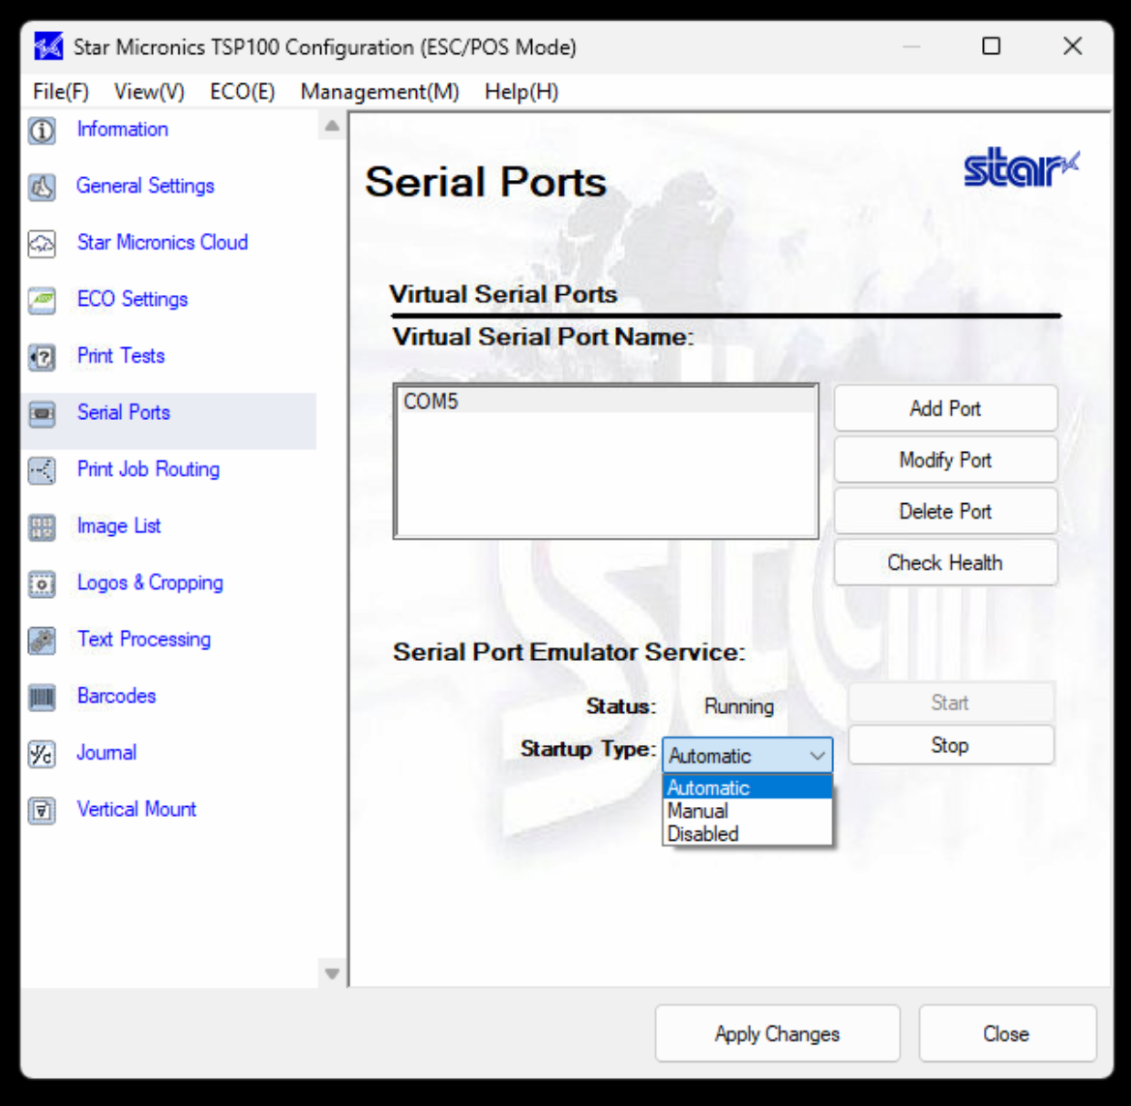
Set the Startup Type to Automatic.
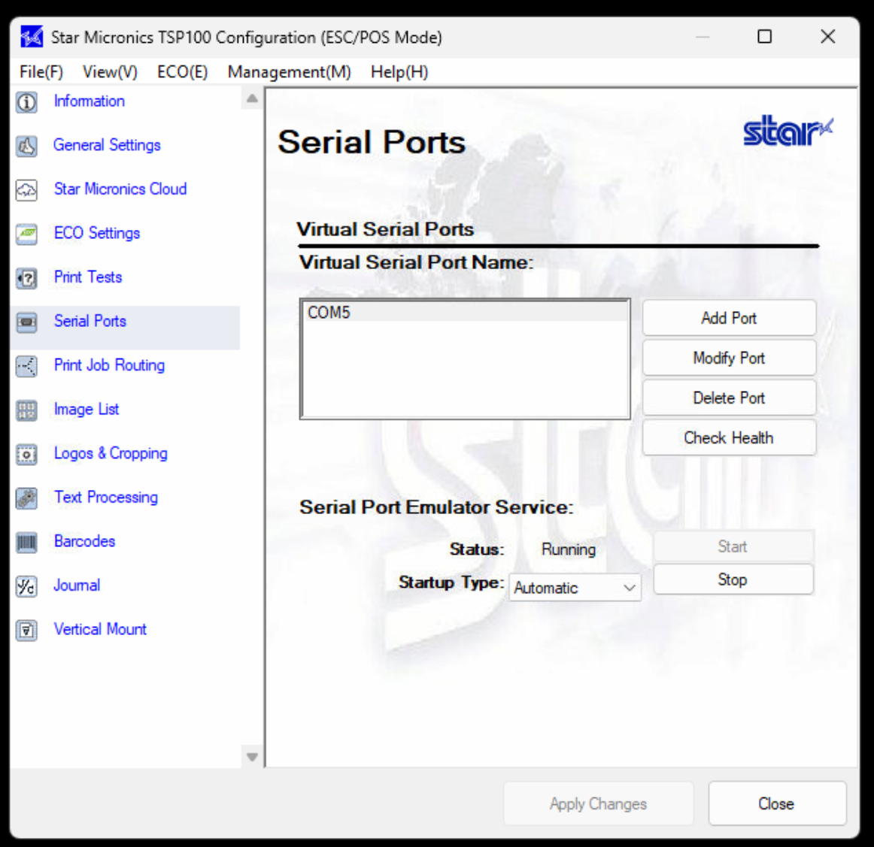
Apply Changes and Start, if not already running.
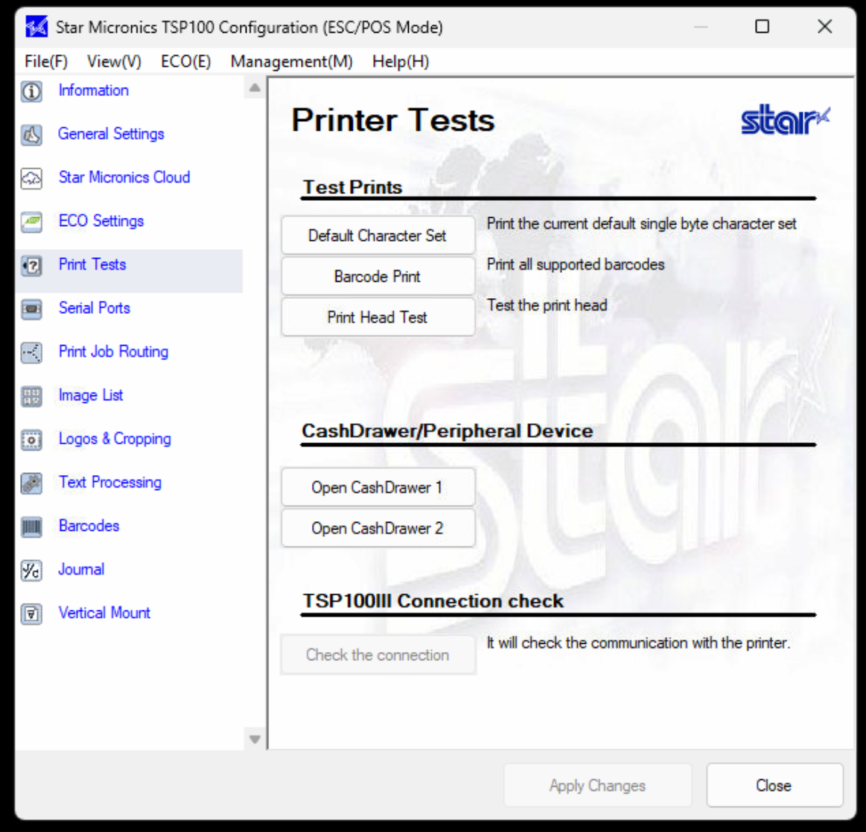
Go to the Printer Tests and Print Head Test to make sure the printer is working correctly.
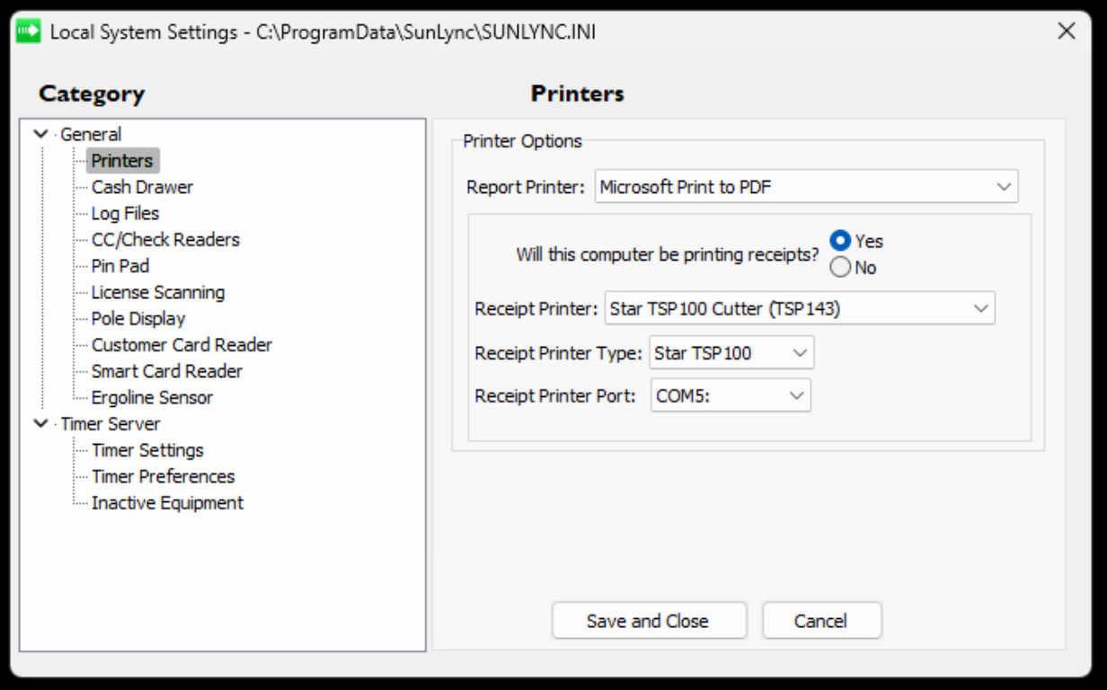
Next open Sun.ini and under the Printers settings. Turn on that the computer will be printing receipts and set the receipt printer type and port.

