All information was pulled from the SunLync Implementation video 7. This will cover report requirements and basic issues.

- Requirements

- In order for a customer to be able to utilize the reporting functions in SunLync they will need to install Crystal Reports on all PCs that will be opening reports. If the customer isn’t sure if they have this, you navigate to Apps & Features on the PC and in the list you should see Crystal Reports:

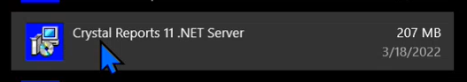

If this is not installed, you should be able to copy the files over and install it on the PC.

The files for this are located on the share drive \\10.13.10.11\Apps\CrystalReports\Crystal_Reports_Engine_Upgrade

Run the Setup Application

- Printers in SunINI. There needs to be something selected for the Report Printer. This cannot be blank. If the customer wants to actually print the report the printer they want to use should be selected. If they want to view the report on their PC, they can simply select Microsoft Print to PDF. Unless the printer is printing receipts leave the No radial button selected.

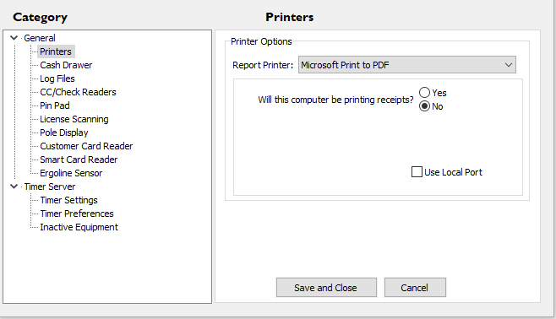

If changes are made be sure to select Save and Close.

- Check the SunLyncDBConnection. Navigate to C:\Program Files (x86)\SunLync\Config on the PC and open the SunLyncDBConnection.

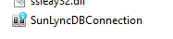

Select the Reports tab and verify that the information is not blank. The information on this tab should match the data on the SunLync tab. Same with the Offline Util.

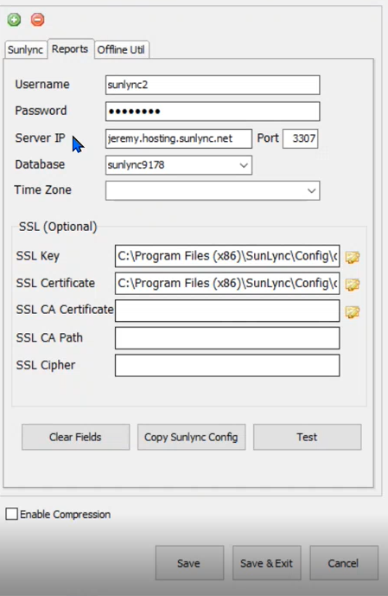

If all the information is complete, you can select Test. If everything is good you should get a pop up saying the connection is ok.

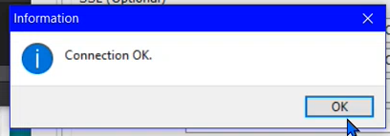

- ODBC Drivers are used by Crystal Reports. If these are not installed the customer may get an error when trying to run a report. To locate if these are installed on the computer or not, navigate to the Control Panel System and Security Administrative Tools. These drivers should be listed.

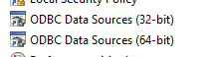

If they are not you will need to install them from the web. Should be ODBC 3.51.

- Testing

Testing a report can be done through the POS or back office. If you’re just doing general testing it shouldn’t matter which, but if you are looking to test a specific report you may need to make sure you’re connected to the correct one.

Navigate to the Reports tab

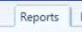

Select Reports

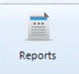

Enter the password if needed.

Locate a report to test, in this example it will be the Daily Sales. Check the box for Run Now next to the report, then select Generate Report(s).

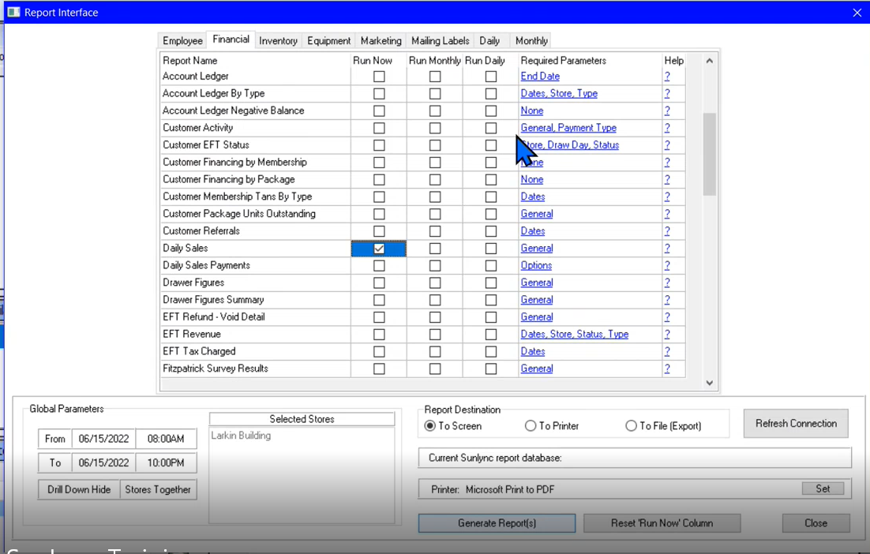

- Troubleshooting/Notes

- If the customer believes data is missing from the report, you can look at the required parameters and verify that they are set correctly.

- The Run Monthly and Run Daily check boxes do not schedule the reports. It will show them in the tabs for Monthly and Daily so the salon can run at one time.

- Management Reports – Backoffice

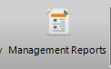

This will provide further reporting options for the customer.

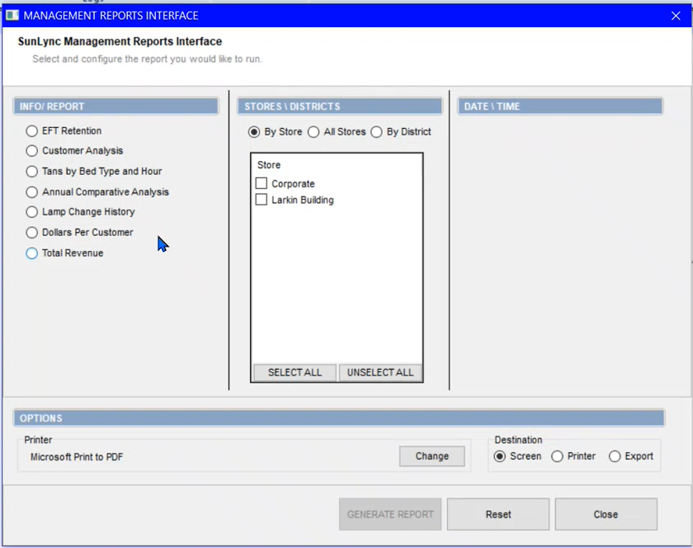

- Offline Utility

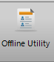

Selecting the Offline Utility will show activity that took place while the system was offline.

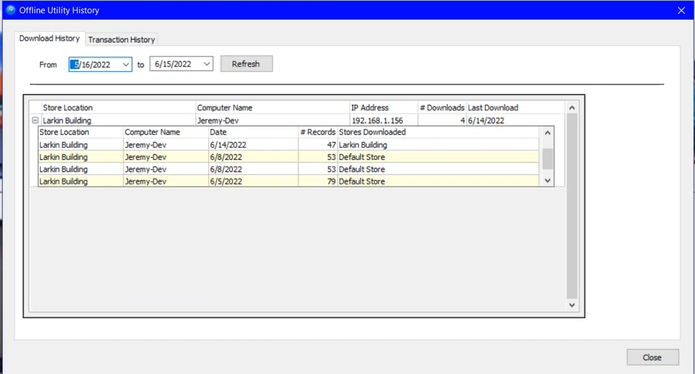

- Data Retrieval – Back Office

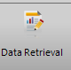

This section is very useful if the customer needs specific information, but you need to be very careful when in it. If you don’t limit the search enough it can lock up the database.

Select the fields to be included in the retrieval by double clicking on them. Note that when you change the drop down menu below Additional Fields it will change the screen to the right. So, any fields selected for a previous option will no longer be seen.

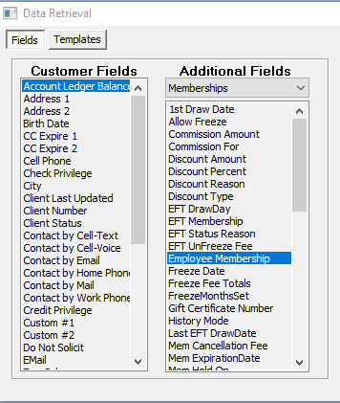

Once you have selected the fields they will be listed in Fields Included section to the right. In this section you can select each field and move them how you would like to see them reported on, or you can clear the data and start over.

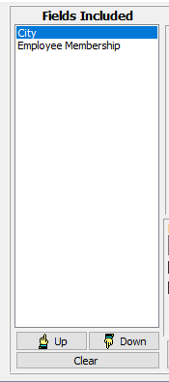

Select the field you would like by double clicking on it. In the Comparison Type drop down you can select how you would like the data compared. Then enter the value to search. Once entered select Accept Filter.

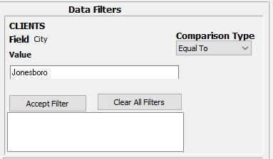

You may want to adjust the Record Limit down as if this number is too high it may lock up the system. Start with about 100. You can also select to exclude and voids or refunds if those would be included in your data retrieval.

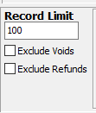

Lastly, if you would like to have the data in a specific order it can be set under the Order By. Select your option from the drop down and then select Add.

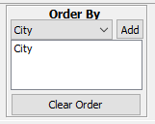

Once all the criteria are set, select Retrieve Data.

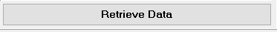

Select Yes on the confirmation pop-up

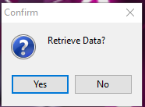

The report should now populate.

