

Affiliated Package Setup in SunLync

This SOP explains what the Affiliated Package feature is and how to access the setup area in SunLync.

What Is an Affiliated Package? 1
How to Set Up an Affiliated Package 1

What Is an Affiliated Package?
An Affiliated Package is a package that is affiliated with an EFT Membership for the purpose of:
- Limiting the number of sessions that can be used on the membership
- Allowing membership sessions to be shared with other customers

How to Set Up an Affiliated Package
- Open SunLync
- Log in to Back Office
- Click the Promotions tab
- Under Packages, select Maintenance
This opens the area where affiliated packages are configured.

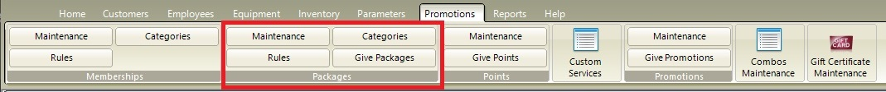
Click the insert button to create a new package. 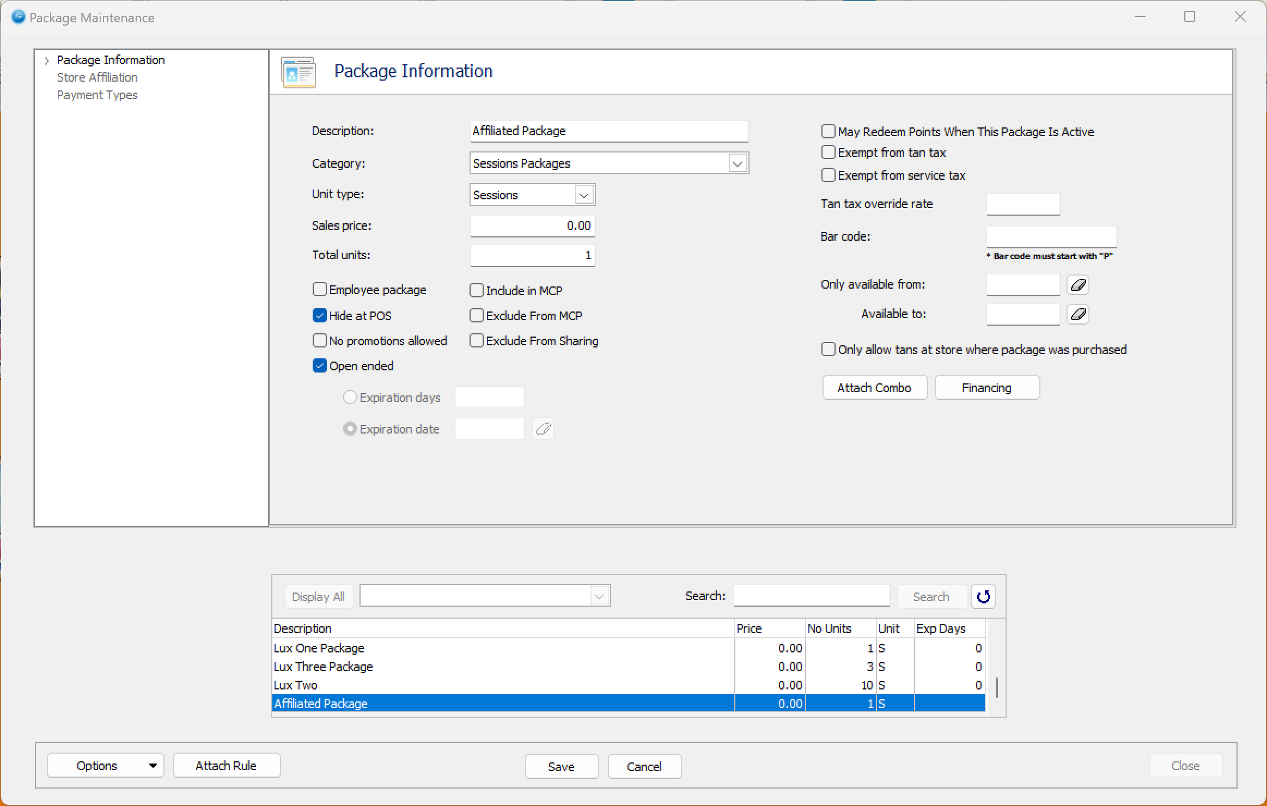
Set up the package as you normally would, with the following exceptions:
- The package must be open-ended with no expiration date
- The package must be hidden at POS
After creating the package, select the stores the package should be affiliated with in the Store Affiliated screen.
Close the Package Maintenance screen.
Click the Maintenance button for Memberships.

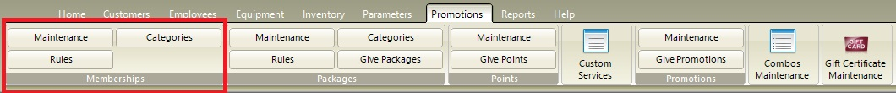
On the Memberships Maintenance screen, Insert the new EFT Membership that will be affiliated with the new package. 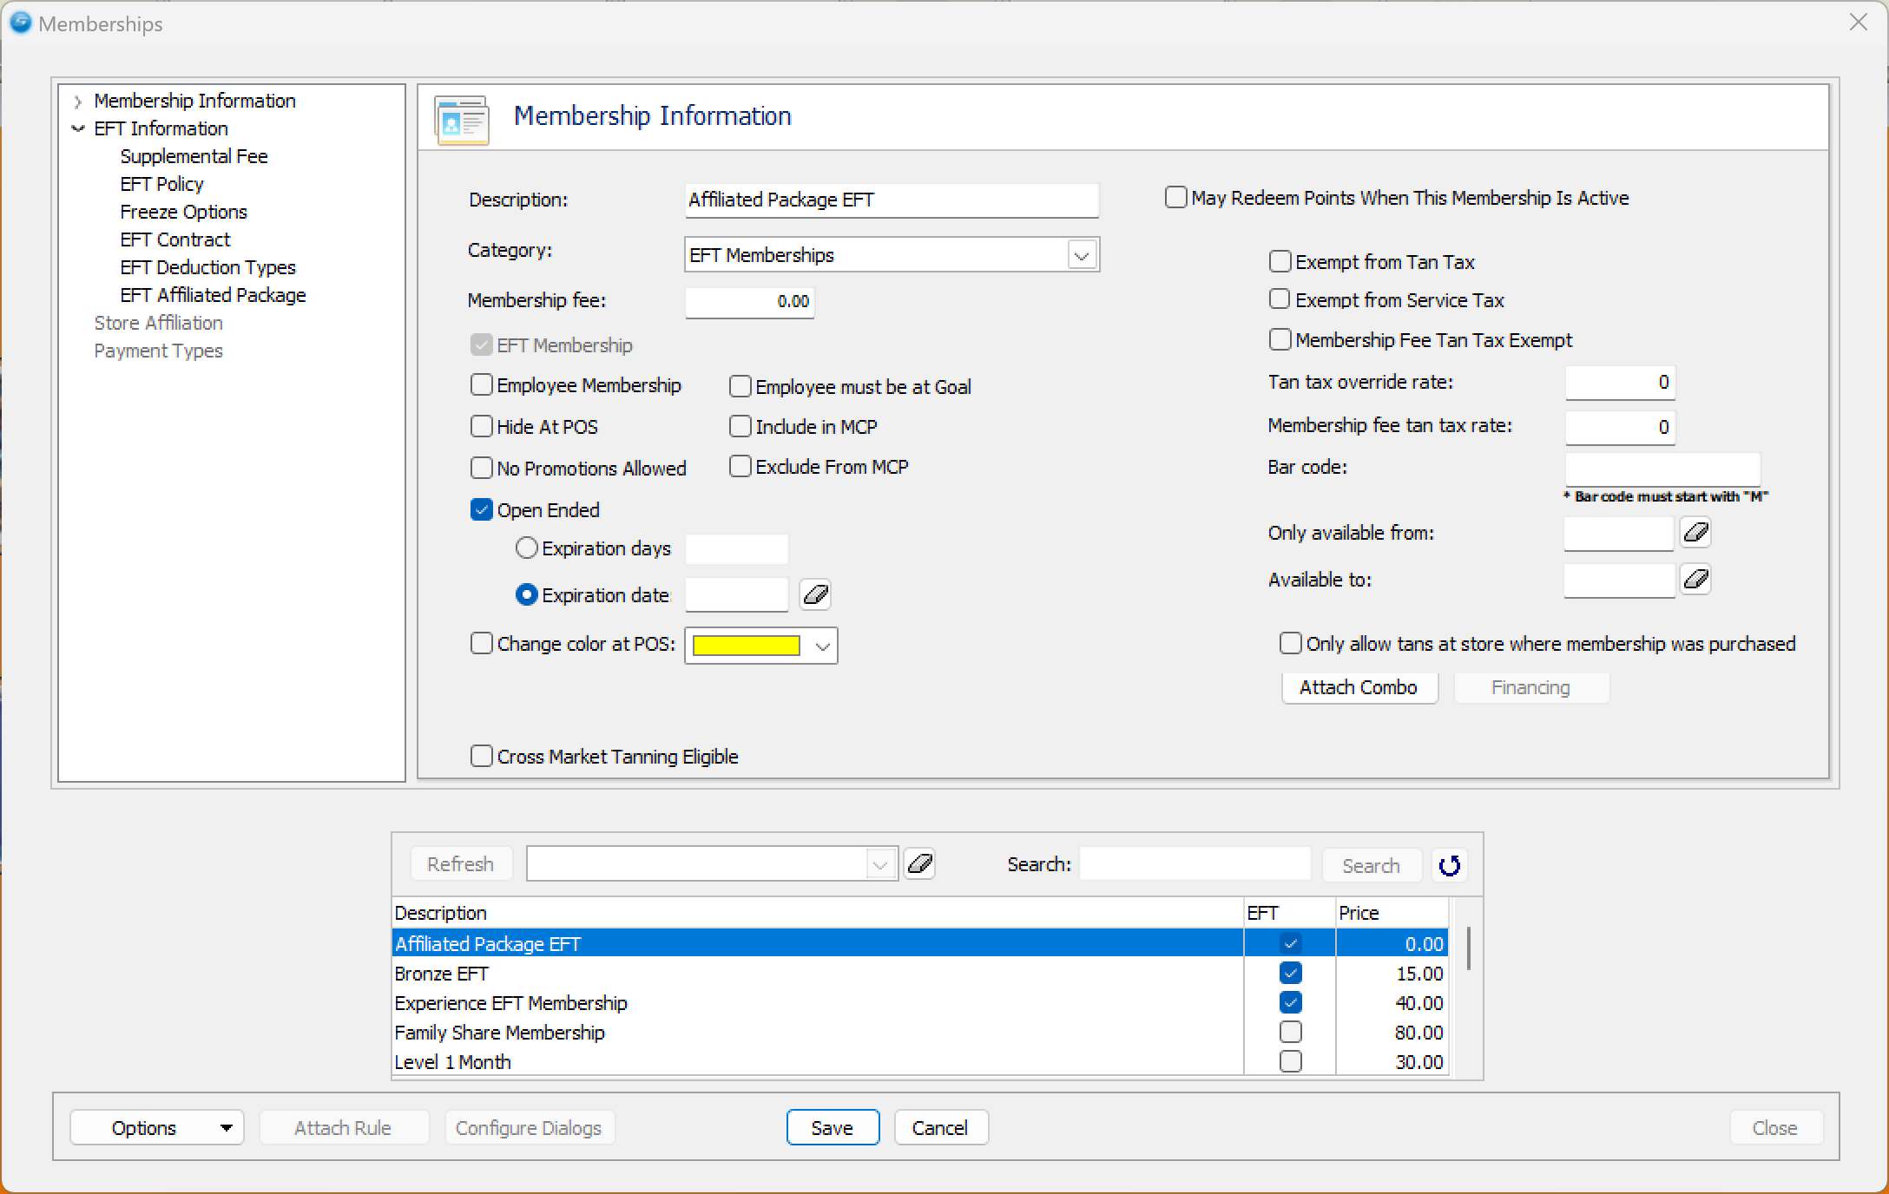
Under EFT Information there is a new section for EFT Affiliated Package. This information is for where the Package will be affiliated with the EFT Membership. 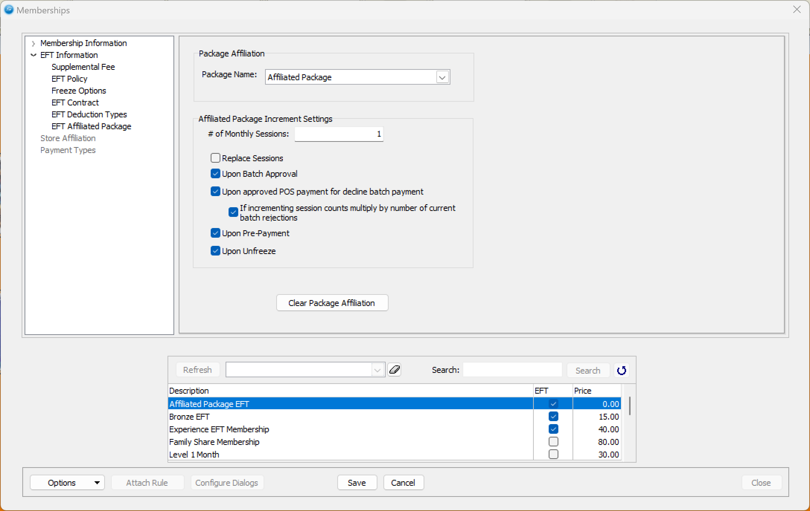
Select the Affiliated Package from the drop-down menu in the Package Affiliation section.
Enter the number of Monthly Sessions to be applied to the affiliated package.
The following checkboxes control when and how the package sessions are updated:
- Replace Sessions – Resets the package sessions to the value entered in # of Monthly Sessions. If unchecked, the package sessions will be incremented by that amount.
- Upon Batch Approval – Increments or replaces the package sessions when a batch approval is posted.
- Upon Approved POS Payment for Declined Batch Payment – Increments or replaces the package sessions when a declined batch payment is successfully paid at POS.
- If Incrementing Session Counts, Multiply by Number of Current Batch Rejections – If multiple rejected batch payments are paid at POS, the system will increment sessions by the # of Monthly Sessions multiplied by the number of rejected payments.
- Upon Pre-Payment – Increments or replaces the package sessions when a pre-payment is made at POS.
- Upon Unfreeze – Increments or replaces the package sessions when the EFT membership is unfrozen, provided it has been frozen for at least one month.
Save the EFT Membership.
Once saved, the EFT membership with the affiliated package will be available for sale.

